



2025 Maternity survey

Statistical release

NHS Patient Survey Programme

Independent analysis for England
Published: December 2025
Contents
Summary of findings 3
Maternity care policy 7
About the Maternity survey 20
Results from the survey 21
Care while pregnant (antenatal care) 24
Care during labour and birth 34
Postnatal care in hospital 47
Postnatal care at home 52
Triage 58
Midwifery continuity of carer 60
Awareness of medical history 64
Infant feeding 67
Perinatal mental health 70
Subgroup analysis 74
Appendix A: Survey methodology 81
Appendix B: Other sources of data related to the key findings 84
Appendix C: Other maternity surveys 86
Appendix D: Main uses of the survey data 88
Appendix E: Revisions and corrections 90
Appendix F: Further information and feedback 92
References 102

Summary of findings
The quality and safety of maternity services is a key focus of national policy, focussing on positive, safe, and equitable experiences of pregnancy, childbirth, and the postnatal period. The Maternity survey gathers feedback from respondents about their experiences of the care provided before giving birth (antenatal care), during labour and delivery, and up to 8 weeks following birth (postnatal care).

In total, 119 NHS trusts in England that provide maternity services and had at least 300 live births during February (and January, where trusts did not have a minimum of 300 eligible births in February) were eligible to take part. Maternity service users who gave birth between 1 and 28 February 2025 (and 1 to 31 January 2025 in trusts with a lower number of live births) were invited to participate. Between April and July 2025, we received responses from 16,755 people – an adjusted response rate of 39%.

The 2025 results overall show improvement when compared to 2024 results, especially in experiences of communication during antenatal care and involvement in decisions during postnatal care.

In particular, 89% of respondents reported they were always spoken to in a way they could understand which is a statistically significant increase of 1 percentage point compared to 2024, with analysis showing a positive 5-year trend. Similarly, 84% reported that their decisions about how they wanted to feed their baby were always respected by midwives. This is also a statistically significant increase of 2 percentage points when compared to results in 2024. In addition, 75% felt healthcare professionals involved them in their care as much as possible which is a statistically significant increase of 3 percentage points when compared to 2024.

Although we have seen improvement in many areas, the 2025 results show no statistically significant change in experiences of communication during postnatal care, with 23% of respondents reporting their midwifery team did not appear to be aware of their or their baby’s medical history (unchanged from 2024).

While we have seen some improvement, a significant minority of people report worries or concerns during pregnancy and childbirth which could have impacted their or their child’s safety. Fifteen per cent of the respondents reported that they felt they were not given appropriate advice and support when they contacted a midwife or the hospital at the start of their labour.

Seven per cent of all the respondents reported being sent home once when they were worried about themselves or their baby, and 3% said that this happened more than once. One in 10 respondents said they were left alone at a time when it worried them ‘during the later stages of labour’ or ‘during the birth’. Nearly one in five (18%) reported that they felt that their concerns were not taken seriously if they raised a concern during their labour and birth.
Positive findings
Antenatal care
The survey results indicate an improvement in verbal communication, with 89% of respondents to the 2025 survey stating that they were ‘always’ spoken to in a way that they could understand, compared with 88% in 2024. Our trend analysis, spanning 5 years and starting with the results from the 2021 survey, shows an upward trend in respondents reporting that they were ‘always’ given enough time to ask questions or discuss their pregnancy (81% in 2025 and 73% in 2021), and in respondents reporting that their midwives ‘always’ listened to them during their antenatal check-ups (84% in 2025 and 79% in 2021).

Our trend analysis also shows an upward trend in respondents being offered mental health support during pregnancy (with 90% answering ‘Yes’ in 2025 and 83% answering ‘Yes’ in 2021).
Labour and birth
Seventy-seven per cent of all respondents reported that they were always involved in decisions about their care which is a statistically significant increase of 2 percentage points when compared to results in 2024.
In hospital after birth and postnatal care
A greater proportion of the respondents reported their partner or someone else close to them was able to stay with them as much as the respondent wanted after the birth (72% in 2025 compared with 63% in 2024).
Eighty-three per cent of the respondents reported being told who to contact if they needed advice about any changes to their mental health after birth. This is a statistically significant increase of 2 percentage points when compared to results in 2024, with our trend analysis showing an upward trend since 2021.
Areas for improvement
Labour and birth

For the first time, respondents whose labour was induced were asked whether they were given information about all the options available to them, including alternatives to induction. A quarter (25%) of the respondents said that they were given information about increased monitoring without induction, while 14% said that they were not given information about all the options available to them.

Triage

Respondents were asked for the first time whether they felt that they got the advice they needed when they contacted the telephone triage line. Nearly three-quarters (72%) answered that they ‘definitely’ got the advice that they needed the last time they contacted the telephone triage line, and 21% answered this happened ‘to some extent’.

In addition, respondents were asked for the first time whether their midwife or doctor listened to them when they attended triage face-to-face. Most (78%) said that their midwife or doctor ‘definitely’ listened to them the last time they attended triage face-to-face, while 17% said this happened ‘to some extent’.

How experience varies for different groups

Our subgroup analysis found disparities in experiences of maternity care across different demographic groups. Respondents were generally more likely to report poorer than average experiences of care if they:
- spoke English as their main language
- were younger (aged 16 to 26)
- had the same midwife ‘some of the time’ or ‘never’ during antenatal care
- did not have continuity of midwives across antenatal care, and labour and birth
- had the same midwife ‘some of the time’ or ‘never’ during postnatal care.
- had an assisted vaginal delivery , a planned caesarean delivery, or an emergency caesarean delivery
- gave birth for the first time

Survey results also show that respondents who reported living in the most deprived neighbourhoods reported poorer than average experiences with regards to being treated with respect and dignity during antenatal care.

Respondents who reported their religion as Jewish reported poorer experiences with regards to being able to get help when needed during care in hospital after birth.
Respondents with a long-term mental health condition reported poorer experiences with regards to being treated with kindness and understanding during care in hospital after birth.

Respondents with pelvic health problems reported poorer experiences with regards to their midwives listening to them during antenatal care, and healthcare professionals doing everything they could to help manage pain during care in hospital after birth. Respondents with another pregnancy-related health condition reported poorer experiences with regards to being involved in decisions during postnatal care.

See the subgroup analysis section for full results of our subgroup analysis, including a full list of themes and subgrou

Maternity care policy
Background to the standards of maternity care
Since the Morecambe Bay Investigation Report in 2015, NHS England’s Maternity Transformation Programme has focused on making care safer, more personalised, and more equitable in maternity and neonatal services. The report’s recommendations, and the government’s acceptance of them, highlighted the need for a national audit of maternity and paediatric services, including a systematic review of perinatal mortality figures and provision of comparative information to trusts.

In 2016, NHS England’s Better Births report, published following the National Maternity Review, identified key improvements needed to achieve the ambition of halving the rates of stillbirths, neonatal and maternal deaths, and intrapartum brain injuries by 2030. The report recommended more personalised care, continuity of carer, integrated care, improved safety, adequate staffing, and perinatal mental health support. The NHS Long Term Plan (2019) subsequently shortened the implementation period to 2025. Progress towards achieving the ambitions has been mixed: more recent data from the Office for National Statistics showed a 25% reduction in stillbirths in 2024 and a 30% reduction in neonatal deaths in 2023. Meanwhile, data from Mothers and Babies: Reducing Risk through Audits and Confidential Enquiries across the UK (2025) (MBRRACE-UK) showed a 5 percentage point increase in maternal deaths between 2021 to 2023 (after excluding COVID-19 deaths).

In 2022, the Ockenden review outlined a set of recommendations, under ‘Immediate and essential actions’, to address safety concerns in maternity services across England. These essential actions included:
- mandatory multidisciplinary training
- minimum staffing requirements
- a mechanism for staff to escalate concerns.

The review also called for clear pathways for induction of labour and neonatal care, as well as emotional and psychological support for women and their families.

In June 2022, a new independent review of maternity care in Nottingham, led by Donna Ockenden, was launched. The review aimed to identify areas of concern in maternity services at Nottingham University Hospitals NHS Trust, and to help improve the safety and quality of maternity care at the trust, including equity and the handling of concerns. The review began in September 2022, and included cases up to May 2025. A report is due to be published in June 2026.
The Maternity and neonatal services in East Kent: 'Reading the signals' report was also published in 2022, following concerns about maternity and neonatal services at East Kent Hospitals University NHS Foundation Trust. The report identified 4 areas for action:
- the development of valid and effective outcome measures
- compassionate care at the core of clinical practice
- measures to improve teamworking through multidisciplinary training and a common purpose
- honesty in responding to challenges and addressing problems.

In 2023, the Black maternal health report reviewed progress to date on the government’s efforts to reduce maternal mortality rates. The report focused on maternal health disparity between Black and White women as well as ethnic disparities more widely, and the overlapping disparity for women experiencing socio-economic deprivation. The recommendations stated that all maternity staff should receive evidence-based training on maternal health disparities, their possible causes, and the delivery of competent, personalised, and evidence-led care. The recommendations also called for the monitoring of Maternity Disparities Taskforce meetings and the implementation of the Equity and equality guidance. Lastly, the report emphasised the need for the relevant stakeholders to deliver data to the National Perinatal Epidemiology Unit in a timely manner, and for NHS England, NHS Improvement, and NHS Digital to capture accurate and complete ethnicity data at a granular level.

In 2024, the Listen to Mums: Ending the Postcode Lottery on Perinatal care report described what needs to improve to address the rates of birth trauma in the UK. The report identified areas for improvement, including:
- providing women with the opportunity to discuss risks and birth options during pregnancy
- enabling women to make informed choices during labour and birth
- providing access to appropriate pain management, and helping with breastfeeding problems during postnatal care
- improving women’s access to specialist perinatal pelvic health clinics during pregnancy and after birth
- offering interpreter support and respecting cultural differences among women who do not speak English as their first language
- ensuring that both women and their partners have access to specialist perinatal mental health services.

In May 2024, the Maternity and Newborn Safety Investigations programme’s National learning report identified factors that affect the delivery of safe care in midwifery units. The report summarised an analysis of 92 investigations carried out by the Health Safety Investigations Branch on or before 14 June 2022, and found 4 main themes. These 4 themes highlighted issues with:
- work demands and capacity to respond, such as the number of tasks, sufficient and suitable staff, and appropriate physical space
- the reliability and sensitivity of intermittent auscultation (‘listening in’) – a method used for monitoring a baby’s heart rate during labour
- organisational preparedness for predictable safety-critical scenarios, including prospective risk assessments and in situ simulations to improve patient safety
- telephone triage with regards to the advice and information given to pregnant women when they are in labour or if they have other concerns – in particular, the recording of information about these calls, and the issue of lost information when women are given multiple numbers for both midwifery and obstetric units.

The Women’s Health Strategy for England (2024) set out the government’s priorities to continue delivering NHS England’s Three year delivery plan for maternity and neonatal services. The strategy reiterated key actions around women’s physical and mental health before, during, and after pregnancy. In addition, it emphasised the importance of women’s understanding of what they can expect from the NHS during pregnancy and after giving birth. The strategy acknowledged the Listen to Mums: Ending the Postcode Lottery on Perinatal care report findings, and committed to improving care and support for women who experience birth trauma to ensure that their voices and choices are listened to. Finally, it accepted the recommendations of the Independent Pregnancy Loss Review – to register baby loss before 24 weeks gestation through a Baby Loss Certificate, and to deliver mandated bereavement training and education for all healthcare professionals.

More recently, the Black Maternity Experiences Report, published in 2025, presented the findings of the second Black Maternity Experiences Survey, which gathered responses from Black and Black-mixed heritage women who had been pregnant between July 2021 and March 2025. The findings highlighted good or high-quality experiences of antenatal care. However, care during labour and birth, and postnatal care identified issues with communication, pain management, and interactions with healthcare professionals. These included respondents’ concerns not being properly addressed, and patients not being given an explanation as to why the pain relief they had requested had been declined. Respondents also stated that they had challenges with healthcare professionals and described discrimination, including issues with race and age. Furthermore, the findings showed that information on how to make a complaint was not available to all respondents, and that a formal process was pursued by less than 1 in 10 respondents (8%).

The 10 Year Health Plan for England (2025) facilitated a new national action plan for maternity and neonatal services, and established a new National Maternity and Neonatal Taskforce. The plan also facilitated a new national independent investigation into maternity and neonatal services, starting with a rapid review of 12 NHS trusts, to be co-produced with:
- families
- Black, Asian, and other seldom heard communities and inequalities experts
- academics and clinicians
- healthcare professionals working in maternity and neonatal care.

Led by Baroness Valerie Amos, the investigation began in summer 2025. Initial findings are due to be published in December 2025, and further findings in spring 2026. The investigation will provide 1 set of national recommendations, based on a synthesis of previous national reviews and current investigations in NHS trusts, to drive improvements in the quality and safety of maternity and neonatal care across England.

In addition, the 10 Year Health Plan for England set out a series of immediate measures to boost the accountability and safety of maternity and neonatal services:
- A new maternity outcomes signal system was implemented across trusts in November 2025 to highlight higher than expected rates of stillbirth, neonatal death, or brain injury. The system was designed to provide early warnings and enable earlier intervention and support.
- A new anti-discrimination programme will be launched to address inequalities in care for Black, Asian, and other underserved communities to boost the accountability and safety of maternity care.
- A new Patient Reported Experience Measure will be launched to gather feedback from women and their families on maternity and neonatal care. The measure will be embedded in all maternity services by 2026.
- A new Single Patient Record will be introduced to bring information about a patient’s medical records together into 1 place, and to give patients access to their medical information.
Standards for maternity care
In March 2023, NHS England proposed the Three year delivery plan for maternity and neonatal services to address the recommendations of the Ockenden review and the Maternity and neonatal services in East Kent: 'Reading the signals' report. The plan identifies a range of measures under 4 high-level themes:
- promoting safe care by listening to women and families with compassion
- supporting the workforce to provide high-quality care by developing skills and increasing capacity
- developing and sustaining a culture of safety
- meeting and improving standards and structures underpinning safer, more personalised, and more equitable care.

The following sections outline the relevant actions set out in the three year delivery plan – these aim to support safer, more personalised, and more equitable maternity care.
Inequalities in care
Women aged 35 or older, those from Black and Asian ethnic minority backgrounds, and those living in the most deprived areas are at increased risk of poorer maternal and baby mortality outcomes. The MBRRACE-UK report for maternal mortality during 2021 to 2023 continues to highlight ongoing health inequalities:
- Women aged 35 or older had a 3.00 times higher risk of maternal death compared with women aged 20-24.
- The risk of maternal death was 2.31 times higher for Black women, and 1.37 times higher for Asian women compared with White women.
- Women living in the 20% most deprived areas had a 1.83 times higher risk of maternal death compared with women living in the 20% least deprived areas.

These disparities in maternal mortality were statistically unchanged from 2020 to 2022.

The MBRRACE-UK report on perinatal deaths of babies born in 2023 highlights ongoing inequalities in mortality rates by ethnicity and socio-economic deprivation:

- Stillbirth rates for Black babies (5.84 per 1,000 total births) were more than twice as high compared with those of White babies (2.71 per 1,000 total births).
- Stillbirth rates for Asian babies (4.69 per 1,000 total births) increased by 9.8 percentage point compared with those in 2022 (4.27 per 1,000 total births).
- Neonatal mortality rates for Black and Asian babies remained significantly higher (2.28 per 1,000 live births, and 2.35 per 1,000 live births, respectively) compared with those for White babies (1.50 per 1,000 live births).
- Stillbirth rates for babies born to mothers living in the most deprived areas (4.23 per 1,000 total births) continued to be higher compared with those for babies born to mothers living in the least deprived areas (2.46 per 1,000 total births). This is the case despite an 8 percentage points decrease in stillbirth rates for babies born to mothers living in the most deprived areas compared with those in 2022 (4.60 per 1,000 total births).
- Neonatal mortality rates for babies born to mothers living in the most deprived areas (2.50 per 1,000 live births) increased for the second year, doubling when compared with those of babies born to mothers living in the least deprived areas (1.03 per 1,000 live births).

NHS England’s three year delivery plan acknowledges significant health inequalities in maternity and neonatal care in England. The NHS approach (Core20PLUS5) to improving equity and equality involves implementing midwifery continuity of carer for women who might need additional support. The improvements include listening to and working with women with compassion, facilitating informed decision-making, providing pain relief options in labour, ensuring access to interpreter services, and ensuring that communications adhere with NHS England’s Accessible Information Standard. To improve care for women and babies from different backgrounds, local data and feedback needs to be collected and disaggregated by population groups to monitor differences in outcomes and experiences.

As part of the three-year delivery plan, integrated care systems are responsible for delivering equity and equality action plans and addressing inequalities in experience for women and babies. These action plans include increasing representation of service users from different backgrounds in integrated care boards (ICBs) and Maternity and Neonatal Voices Partnerships (MNVPs) to co-produce national policy.

The NHS People Plan states that ‘where an NHS workforce is representative of the community that it serves, patient care and the overall patient experience is more personalised and improves’. NHS England has committed to addressing workforce inequalities by monitoring the Workforce Race Equality Standard and the Workforce Disability Equality Standard. In addition, it has developed the nursing and midwifery anti-racism resource framework to help nursing and midwifery professionals to recognise and challenge racial discrimination and, in doing so, promote wellbeing, and physical and psychological safety.

In August 2022, the Care Quality Commission’s National maternity inspection programme inspected 131 NHS acute hospital maternity services that had not been inspected and rated since March 2021. The programme focused on the safety and leadership of maternity services and shared examples of good practice. Published in September 2024, it acknowledged significant challenges to maternity services, both nationally and locally, emphasising the need for national action.

The findings showed that, while some trusts were making improvements to address health inequalities, there was more that could be done to ensure that people’s needs are met when delivering their care. The findings demonstrated that having poor or no spoken English was related to worse experiences of maternity care. The report recommended that ICBs should improve their collection of demographic information, including that on ethnicity and deprivation levels.

Alongside the National Maternity Inspection Programme, CQC has published the Maternity improvement resource to set out the characteristics of good health care equity, including:
- communicating with women, their families, and their carers about their diverse needs and reasonable adjustments they might require to access maternity services
- collecting ethnicity data in incident reporting
- providing translation and interpreter support, and making adjustments to meet women’s communication needs
- promoting equality and diversity within the maternity workforce
- encouraging and involving all staff, including those with protected equality characteristics, to enable inclusive maternity services and culture.

NHS England’s 2024/25 priorities and operational planning guidance re-emphasises the commitment to reduce health inequalities through the delivery of the Core20PLUS5 approach. In March 2025, NHS England announced a new Maternity and Neonatal Board, which oversees progression in the delivery of a safer, more equitable workforce in maternity and neonatal services. The Board will bring together maternity leaders, clinicians, and representatives from MNVPs to ensure that national commitments are implemented consistently at local level.

By May 2025, every Local Maternity and Neonatal System (LMNS) published its plans on how the Equity and equality guidance would be implemented. These plans outline how the LMNSs will reduce disparities in health outcomes among women from Black, Asian, and ethnic minority backgrounds, and women living in the most deprived neighbourhoods. Online cultural competence and safety training, developed in collaboration with the Royal College of Midwives, was made available to all staff. In addition, 140 sites received clinical training aids to support the safe assessment of women and babies with Black or dark skin tones.

In June 2025, NHS England’s letter to trusts and ICBs providing maternity and neonatal care requested that NHS boards accelerate their plans to provide enhanced continuity of care in the most deprived neighbourhoods.

Safety and personalised care

NHS England’s three-year delivery plan aims to offer all women personalised care and support plans. The plan commits to ensuring that pregnant women and new mothers have access to specialist perinatal pelvic health and mental health services, that women and families who have experienced baby loss have access to bereavement services 7 days, and that all women have access to neonatal care, when needed.

It also identifies informed decision-making and informed consent as being essential elements of providing safe and personalised care. The ambition is that women should be offered a choice at all stages and in all aspects of pregnancy, including a choice of birth setting, pain management during the birth, the involvement of their birth partner, and how to feed their baby. These should be informed by an individual clinical risk assessment, recorded in a personalised care and support plan, and reviewed on an ongoing basis at each contact. NHS England guidance on implementing personalised care describes the role of LMNSs and MNVPs in ensuring that personalised care is embedded in service delivery.

To help facilitate safer and more personalised care, the three-year delivery plan sets out the time, training, tools, and information that maternity and neonatal staff need to deliver compassionate and kind care. It acknowledges that trusts are responsible for undertaking regular audits and seeking feedback from women and parents to monitor the delivery of personalised care. In addition, it proposes the delivery of midwifery continuity of carer in line with the safe staffing principles described in a letter to trusts in September 2022. Finally, it outlines that trusts are required to support women with practical advice and information that reflects how they choose to feed their babies – in so doing, they should achieve the UNICEF UK Baby Friendly Initiative standard for infant feeding by March 2027.

NHS England’s GP six-to-eight-week maternal postnatal consultation – what good looks like guidance, published in December 2023, provides national guidance for the delivery of safer, more equitable, and more personalised care in GPs’ maternal postnatal consultations. The guidance sets out that women should be offered an appointment that is separate from the baby check (though both appointments may be run consecutively). The maternal postnatal consultation should be offered to all women, tailored to their personal circumstances, and GPs should take into account equity in access, and experiences and outcomes for specific groups. It should focus on the following areas of physical and mental health, which might impact each other:
- mental health and general wellbeing
- experience of the birth
- difficulties with feeding a baby(s)
- wound healing and discomfort
- perineal pain and pelvic health problems
- management of pre-existing medical problems and significant medical conditions arising due to pregnancy or breastfeeding
- contraception and family planning
- health promotion related to smoking cessation, weight, physical activity, cervical screening, and vaccination programmes.

CQC’s National Maternity Inspection Programme report for 2024 stated that women did not always receive the information that they needed to process what happened to them in a way that enabled them to make informed decisions about future pregnancies. This is consistent with the Listen to Mums: Ending the Postcode Lottery on Perinatal care report, which found that many women felt that they had not been given enough information to make decisions during labour and birth, and that poor care was all too frequently tolerated as normal.

The Maternity Services dashboard, published in 2024, was developed to enable clinical teams to compare their performance with that of their peers on a set of nationally agreed indicators. These indicators cover 5 different domains including mortality and morbidity, choice and continuity of carer, clinical care and health promotion, organisational culture, and user experience. The dashboard also displays descriptive statistics and demographic data about the maternity population and activity within a given provider, such as the number of bookings, deliveries and births, maternal age, body mass index, and ethnicity. The data is sourced from monthly Clinical Quality Improvement Metrics and annual National Maternity Indicators to identify areas for quality improvement.

NHS England’s 2024/25 priorities and operational planning guidance continues to highlight the importance of personalised and safe care, including the provision of a personalised care plan and support with informed choices for every woman. The guidance also sets out the implementation of best practice through early warning tools and reviews of the progress made toward positive safety culture at the board level.

NHS England’s Saving babies lives: version 3, published in 2025, sets out refreshed elements of the previous versions of the Saving Babies Lives Care Bundle, adding a new element that focuses on the management of pre-existing diabetes in pregnancy. The revised care bundle aims to reduce perinatal mortality through the implementation of 6 elements, including:
- reducing smoking in pregnancy
- assessing, monitoring, and managing foetal growth
- raising awareness of reduced foetal movement
- promoting foetal monitoring during labour
- reducing preterm birth
- managing pre-existing diabetes for women with Type 1 or Type 2 diabetes.

Perinatal mental health

Perinatal mental health relates to mental health problems experienced during pregnancy or within a year after childbirth. NHS England states that as many as 27% of pregnant women or new mothers report mental illness. If left untreated, mental health problems can have significant and long-term effects on the wellbeing of women, their babies, and their wider families.

The Royal College of Psychiatrists recommends that women with moderate and severe mental health illness are provided with access to specialist perinatal mental health services in the perinatal period and when planning a pregnancy. Specialist perinatal mental health services are responsible for assessing and treating maternal mental health illness, and assessing and supporting the mother-infant relationship. They also collaborate with partners and other family members to help them to support women in their recovery, and they provide support to partners in developing their relationship with their baby. This support includes assessing the partner’s mental health needs and signposting them to the appropriate services where indicated. In addition, primary, maternity, and health visiting services are responsible for ensuring that women’s mental health needs are met by asking them about their current and past mental health at all routine antenatal and postnatal checks.

NHS England’s three-year delivery plan states that ICBs are responsible for commissioning and implementing community perinatal mental health services to improve the availability of specialist mental health care for all women. The NHS Long Term Plan commits to ensuring that a minimum of 66,000 women facing moderate to severe mental health difficulties have access to specialist perinatal mental health services by 2023/24, with NHS England’s 2024/25 priorities and operational planning guidance reiterating this commitment.

CQC’s National Maternity Inspection Programme report for 2024 highlighted that many women report significant mental health concerns before, during, and after birth, and 4 to 5% of women develop post-traumatic stress disorder every year after giving birth. The findings showed that while some trusts focus on the impact of inequalities on mental health, this was not consistent across the services that we inspected.

In the May 2024 update on the delivery of the NHS England’s three-year delivery plan, it is reported that 39 maternal mental health services that provide specialist care for women who need it are established. The NHS Mental Health Dashboard shows that more than 63,000 women accessed specialist perinatal mental health services, including maternal mental health services, between January and March 2025.

Staffing

Staffing, leadership, and mandatory training are essential to the safety and quality of maternity care and the workplace culture. The Ockenden review highlights staffing and training gaps in maternity services, and recommends that all maternity units in England have an escalation policy for cases in which staffing falls below the recommended minimum level. It also states that additional mandatory training should be undertaken across the maternity workforce to meet organisational requirements.

The Royal College of Midwives’ survey of midwives and maternity support workers in England (2024) found that nearly 9 in 10 (87%) respondents did not feel that their workplace had safe staffing levels. Similarly, nearly 9 in 10 (88%) respondents reported that they had worked additional unpaid hours in the first week of March 2023, with more than 1 in 4 (26%) respondents reporting that they had worked more than 5 additional unpaid hours in that period. Finally, 64% of the respondents answered that they felt burnt out or exhausted at the end of ‘most or all’ of their working shifts, with more than 1 in 4 of all respondents (26%) answering that they felt burnt out or exhausted at the end of ‘every’ working shift.

In May 2025, the NHS England workforce statistics showed an increase of over 1,300 full-time equivalent midwives compared with May 2024. National-level results from the 2024 NHS Staff Survey showed that the majority (69%) of midwives ‘disagree’ or ‘strongly disagree’ with the statement, ‘There are enough staff at this organisation for me to do my job properly’. This is compared with just under half (44%) of a general occupation group of registered nurses and midwives who ‘disagree or ‘strongly disagree’ with this statement.

NHS England’s three-year delivery plan states that sufficient capacity can only be achieved by skilled teams. The plan includes a commitment to ensure that all staff have the necessary training, supervision, and support to perform to the best of their ability. The core competency framework, which informs local training programmes, ensures that the skills relevant to the roles of staff are kept up-to-date. It sets out that training should be multidisciplinary wherever practical to optimise teamworking. The plan also highlights that trusts are responsible for developing and implementing local plans to fill vacancies, supporting newly qualified staff and clinicians returning to practice, and providing administrative support to free up pressured clinical time.

CQC’s National Maternity Inspection Programme report for 2024 identified recruitment and retention of midwifery and obstetric staff as a priority improvement to maintain safe staffing levels, along with supporting midwifery staff with appropriate and ongoing training. The programme acknowledged that there is good oversight of staffing levels and skill mix in line with NHS best practice across many services. However, a few services lack sufficiently skilled and experienced staff to appropriately assess, care for, and mitigate risks for all women. The report described 3 elements of effective workplace culture: openness, empowerment of staff, and continual learning and improvement. Lastly, the report emphasised that effective leadership, governance, and culture are key to patient safety and staff wellbeing, and recognised that system leaders are responsible for prioritising maternity service improvements.

CQC also published the Maternity improvement resource, which sets out the characteristics of good leadership and culture, including:

- compassion and supportive relationships at every level
- promoting staff empowerment and encouraging staff to actively raise concerns
- sharing collective responsibility for care
- actively promoting equality and diversity within the maternity service
- addressing the causes of any workforce inequality.

NHS England’s 2024/25 priorities and operational planning guidance emphasises its commitment to retaining and growing the maternity and neonatal workforce, and investing in the skills and capacity of the workforce.

Midwifery continuity of carer

A Cochrane review found that women receiving consistent care from a small group of midwives during pregnancy and childbirth were less likely to experience preterm births, and required fewer interventions during labour and delivery when compared with others, whose care was divided between different obstetricians, GPs, and midwives.

NHS England’s three-year delivery plan sets out that trusts are responsible for considering the roll out of midwifery continuity of carer (MCoC) in line with the safe staffing principles outlined in September 2022. These principles remove the national target for delivering MCoC and emphasise growing and retaining the maternity workforce in line with the recommendations of the Ockenden review. These changes were made to ensure that safe staffing levels can be maintained across England while services also provide more specialised care to women from vulnerable groups that will benefit the most from it. Trusts are permitted to continue with their existing MCoC models and expand them further, provided that they can demonstrate safe minimum staffing levels.

The May 2024 update on the delivery of NHS England’s three-year delivery plan states that 34 MCoC teams are in place and a further 210 MCoC teams are funded in 2024/25 with the condition that the maternity workforce continues to grow.

Triage

The Royal College of Obstetricians & Gynaecologists’ Good Practice Paper No. 17 on Maternity Triage, published in 2023, sets out the standards for supporting pregnant or newly postnatal women (up to 6 weeks) who have unscheduled related concerns or problems. The guidance describes a set of recommendations on the operational structure and pathways within maternity triage to improve patient safety and experience. It also outlines the provision of minimum staffing requirements for maternity triage departments.

The paper recommends that women should be offered clear information on when and how to call or attend the maternity triage unit. This information should be provided in a format and language that can be readily accessed and understood. Interpreting and translation services should be made available to all patients free at the point of delivery of the service. Requests to attend hospital should be documented, and services users should receive information about the urgency of their clinical concern and the timeframe during which they should attend the maternity triage unit.

The guidance also states that a brief initial assessment, and prioritisation of urgency, should take place within 15 minutes of service users attending the maternity triage unit. This assessment should be undertaken by a midwife trained in a specific triage method and using a standardised tool (for example, the Birmingham Symptom specific Obstetric Triage System).

Reduced foetal movements are one of many concerns that require unscheduled attendances to the maternity triage unit during pregnancy. A horizon scanning project (2025), carried out by Sands and Dr Tomasina Stacey from King’s College London, identified several challenges in discussing foetal movements during pregnancy. The evidence gathered through focus groups with bereaved and non-bereaved parents, healthcare professionals, and third sector organisations found 3 areas of challenge:
- how core information is shared and received as part of routine antenatal care, and the importance of women being able to identify an important change in a baby’s movement and knowing when to report it
- accessibility of care and barriers to access to providers, which prevent women from sharing concerns about a baby’s movements and receiving the right care
- the response when accessing care – particularly where women are dismissed, uncertain, or overly reassured during the initial contact with healthcare professionals – and the likelihood of women attending care appointments or seeking help in the future.

Accessibility, equity, and trust were identified as the important barriers to improving information, advice, and care around foetal movements during pregnancy.

CQC’s National Maternity Inspection Programme report for 2024 stated that the assessment and prioritisation of clinical risk should take place for all women who contact maternity triage. However, significant variation was found across maternity services. In particular, the report identified issues with telephone triage, and reporting and monitoring waiting times for assessment in on-site triage as priority areas for improvement. Another area for improvement was found in research from the Sands and Tommy’s Joint Policy Unit, which showed variation in guidance on how and when to contact maternity triage and in information provided to pregnant women on key topics such as bleeding, waters breaking, and reduced foetal movements.

CQC’s Maternity improvement resource outlines the characteristics of good triage processes, which include:
- protecting women and their babies from avoidable harm
- clearly defining in-person and telephone triage processes
- collecting and monitoring service users’ outcomes and feedback on triage care and treatment
- auditing triage services through board oversight of activity.

About the Maternity survey
The Maternity survey asks women about their experiences of care across the entire maternity pathway. It is part of a wider programme of NHS surveys, which cover a range of topics that include the experiences of:

- adults admitted to hospital as acute inpatients
- adults who received care from an emergency department or an urgent treatment centre
- people who received care in the community for a mental health condition
- children and young people who have been admitted to hospital as inpatients or day cases.

The 2025 Maternity survey involved 119 NHS trusts in England. All NHS trusts providing maternity services that had at least 300 live births during the sample months were eligible to take part. Women who gave birth between 1 and 28 February 2025 (and 1 and 31 January 2025 if a trust did not have a minimum of 300 eligible births in February) were invited to take part in the survey. Trusts with fewer than 300 births were able to take part in the survey on a voluntary basis. Fieldwork took place between April and July 2025. Responses were received from 16,755 people – an adjusted response rate of 39%.

Although this survey has been running since 2007, the data collected this year can only be compared back to 2013 following major redevelopment work. Where possible, changes to questions are limited to monitor trends over time. However, where necessary, questions are amended to reflect changing policy and survey best practice.
For more information about changes to the questionnaire and survey development, see the 2025 Maternity Survey Development Report on the NHS Patient Surveys website. Appendix A provides more information on the methodology, which covers how we developed the survey, analysed data, and compared results with previous surveys.
Results from the survey
This section presents the key results from the 2025 Maternity survey, which asks women about their experiences of maternity services in England, including antenatal care, labour and birth, and postnatal care.

Where we have data for a minimum of 5 years (2021, 2022, 2023, 2024, and 2025), it is included as part of our trend analysis using a ‘generalised linear model’. This is to determine whether there has been an upward or downward trend over this period. This analysis uses the most positive (‘top box’) responses to identify significant change over time.

The rationale for using only the 5 most recent time periods within this analysis is two-fold. Firstly, the most recent data is considered the most applicable for understanding people’s recent experiences of maternity services. To analyse any trend, multiple years of data are required, and using the 5 most recent data points is seen as a suitable compromise between having enough data for the trend analysis to be applicable and not going so far back as for the data to be no longer representative.

Secondly, to allow for the optimum detection of changes in long-term trends, limiting the trend analysis to the 5 most recent years avoids a scenario where any decline or improvement in the early years has become ‘baked into’ the results. With 10 years of data available for the Maternity survey, it could take many years of improvement or decline before an overall trend were detected if we included each time point in the analysis.

This is illustrated with a hypothetical example in figure 1, where the line of best fit continues to show a decline even though new data points indicate an upward trajectory.

Figure 1: Line of best fit example with later upward trajectory


Figure 2 shows an example of a trend analysis graph that contains data for 10 years. Such a graph will be used throughout the results section. Analysis carried out on the most recent 5 years (2021, 2022, 2023, 2024, and 2025) shows a trend of improvement since 2021.

Figure 2: Example of trend analysis graph

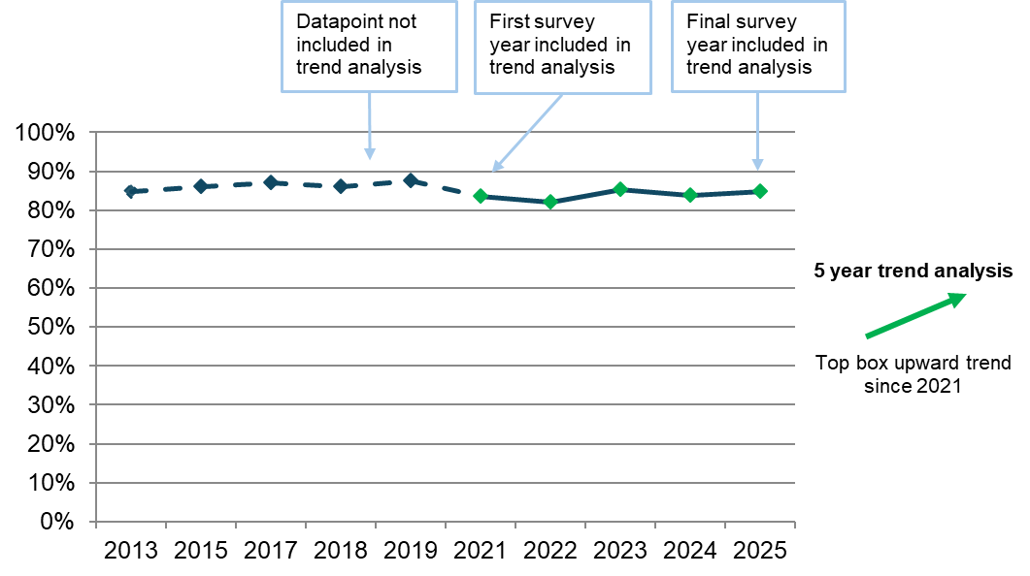

The arrow next to the graph above clearly states whether there is a trend and if that trend is upward or downward. For all trend analyses included within this report, a significant finding is classed as a p value <0.05. A statistically significant difference means that there is a less than 5% chance that we would have obtained this result if there was no real difference. Trend analysis will be reported where statistically significant differences have been found.

For questions where 5 years of data is not available, charts have been used to show results for each survey year where data is available. Statistically significant differences have been highlighted with arrows added to charts to show the direction of change. Where previous data is not described, or arrows are not used in charts, there is no statistically significant change.

Both the NHS Constitution and the Equality Act 2010 require healthcare providers to equally consider the needs, experiences, outcomes, and aspirations of people with protected characteristics under equalities law. In this section, we also include some of the key results of our subgroup analysis, which compares how the experiences of people vary according to their demographic or personal characteristics. These characteristics are:
- age
- parity (whether women have had a previous baby or not)
- type of delivery
- ethnicity
- religion
- sexual orientation
- gender the same as that assigned at birth
- Indices of Multiple Deprivation (IMD) decile
- long-term health conditions
- pregnancy-related conditions
- whether English is spoken as their main language
- frequency of contact with the same midwife during antenatal care
- frequency of contact with the same midwife during postnatal care
- continuity of midwives across antenatal care, and labour and birth

Survey results are reported under the following key sections:
- care while pregnant (antenatal care)
- care during labour and the birth
- postnatal care in hospital
- postnatal care at home
- triage
- midwifery continuity of carer
- awareness of medical history
- infant feeding
- perinatal mental health
- subgroup analysis

Note: responses to questions such as ‘don't know/can’t remember’ are not shown and are excluded from percentage calculations. Other non-specific response options are also excluded, such as where the respondent does not require the experience/service, for example, and not needing or wanting to be involved in decisions about their care.

Care while pregnant (antenatal care)

The survey included 10 antenatal care questions that can be analysed over a 5-year period. All 10 questions, including those on people being listened to by midwives, and on being spoken to in a way they could understand, show statistically significant improvement since 2021.

Similarly, of the 15 questions for which comparison with 2024 data is available, all 15 show a statistically significant positive change - including those on people being treated with respect and dignity, and on being given information about any warning signs to look out for during their pregnancy.

Informed choice

The National Institute for Health and Care Excellence’s (NICE) guidance on intrapartum care recommends that women should be given the explanation that they may choose any birth setting (home, freestanding midwifery unit, birthing centre, or obstetric unit) and their choice should be supported by staff.

Results from the 2025 Maternity survey show that 72% of women were offered a choice of birth setting. In particular, more than half (59%) of women were offered a choice of hospitals. The results also show that:
- 29% were offered a choice of birth centres
- 18% were offered a home birth
- 3% were offered ‘other’ choices.
- 12% were not offered any choices
- 8% stated that they did not have any choices due to medical reasons.

More than half (58%) of the respondents said that they ‘definitely’ received enough information from either a midwife or doctor to help them decide where to have their baby – a statistically significant increase compared with the proportion in 2024 (55%). More than a quarter (27%) said that they received this information ‘to some extent’, which is consistent with the results in 2024. Meanwhile, 15% said that they did not receive enough information to help them decide where to have their baby – a statistically significant decrease compared with the proportion in 2024 (18%). Figure 3 shows that there has been a significant upward trend since 2021 (58% answered ‘Yes, definitely’ in 2025, compared with 47% in 2021).

Figure 3: Did you get enough information from either a midwife or doctor to help you decide where to have your baby? (% Yes, definitely)

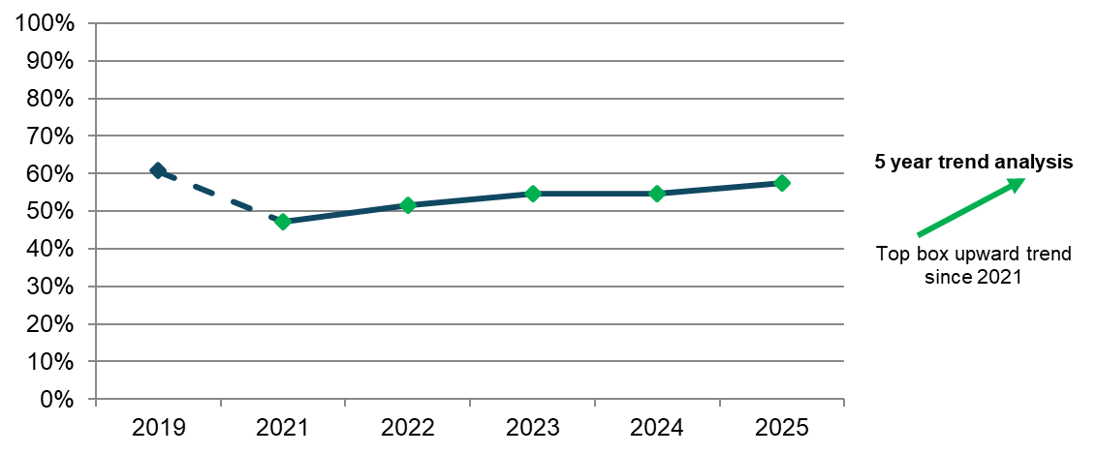
Answered by all. Respondents who stated that they didn't know or couldn't remember have been excluded. Total number of the respondents: (2019) 16,651, (2021) 22,709, (2022) 19,969, (2023) 18,145, (2024) 18,149, (2025) 16,016.

As noted in NHS England’s three year delivery plan, involvement in decisions about maternity care, and collaboration between service users and the staff caring for them help to provide safer, more personalised, and more equitable care in maternity and neonatal services. This includes ensuring that women have clear choices supported by unbiased information and evidence-based guidelines, and open and honest dialogue with their midwives and clinicians about the care they want and any outcomes that are not as expected.

The majority (82%) of the respondents said that they were ‘always’ involved in decisions about their antenatal care, a significant increase compared with 80% in 2024. Results of our trend analysis show an upward trend since 2021 (77%, figure 4).

Figure 4: Thinking about your antenatal care, were you involved in decisions about your care? (% Yes, always)

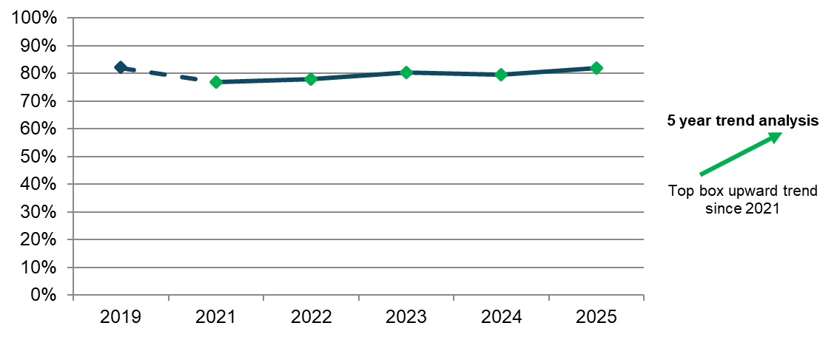
Answered by all. Respondents who stated that they didn't know or couldn't remember or did not want or need to be involved have been excluded. Total number of the respondents: (2019) 16,629, (2021) 22,822, (2022) 20,382, (2023) 18,523, (2024) (18,491), (2025) 16,343.

Results for being involved in decisions during antenatal care show poorer experience for respondents:
- who had the same midwife 'some of the time’ or 'never' during antenatal care, or who did not have the same midwife during postnatal care
- who had an emergency caesarean birth.

Information

NICE guidance on antenatal care states that women should receive information about how to contact the maternity service about urgent concerns, such as pain and bleeding, at their first antenatal appointment and later if appropriate. They should also be offered a risk assessment to monitor foetal growth.

Respondents were asked whether they were given information during antenatal care about any warning signs to look out for during their pregnancy. More than three-quarters (77%) of the respondents said that they were ‘definitely’ given this information, a small statistically significant increase compared with 76% in 2024. The remaining 4% said that they were not given this information, consistent with the results in 2024 (figure 5).

Figure 5: Thinking about your antenatal care, were you given information about any warning signs to look out for during your pregnancy? By survey year

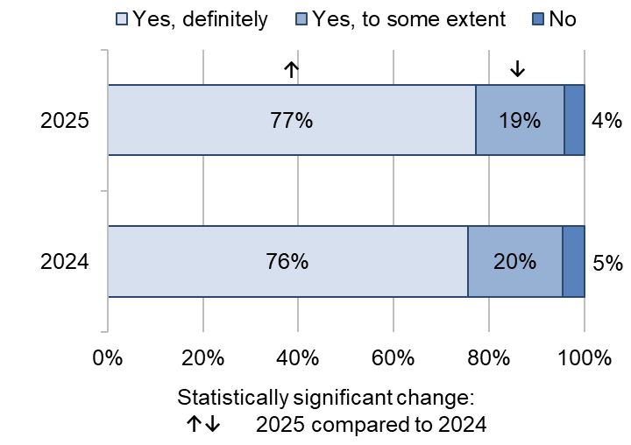

Answered by all. Respondents who stated that they didn't know or couldn't remember have been excluded. Total number of the respondents: (2024) 18,509, (2025) 16,353.

Communication and compassionate care

NICE guidance on antenatal care outlines several key principles for communication, including:
- listening to women and responding to their needs and preferences
- discussing the risks, benefits, and implications of any assessment, intervention, or procedure
- respecting women’s decisions even when this is contrary to the views of the healthcare professional
- using clear language, and tailoring information to women's needs and preferences and their stage of pregnancy
- checking that the woman and her partner understand the information and how it relates to them
- providing regular opportunities to ask questions, and setting aside enough time to discuss any concerns.

Most respondents (84%) said that their midwives ‘always’ listened to them, which is a small statistically significant increase compared with 83% in 2024. A further 14% said they ‘sometimes’ felt listened to, which is a small statistically significant decrease compared with 15% in 2024. Figure 6 shows that there has been a significant upward trend over a 5-year period since 2021 (84% answered ‘yes, always’ in 2025 compared with 79% in 2021).

Figure 6: During your antenatal check-ups, did your midwives listen to you? (% Yes, always)

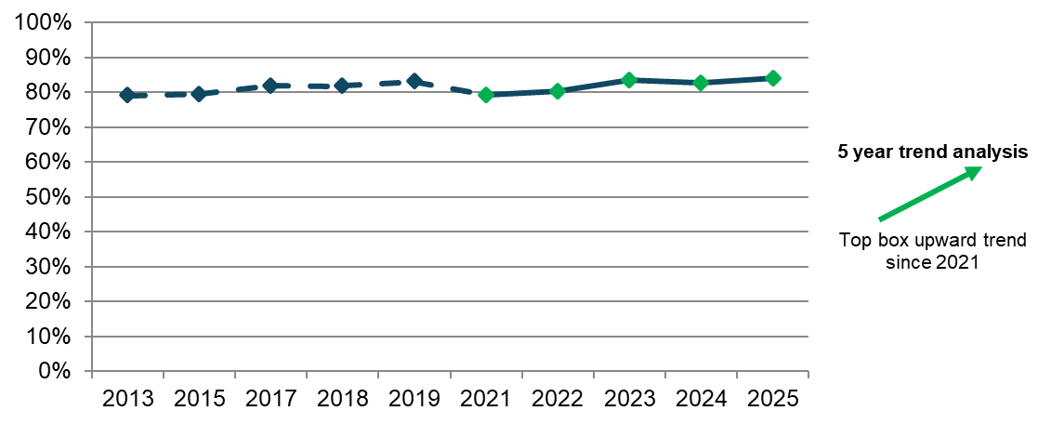
Answered by all. Respondents who stated that they didn't know or couldn't remember have been excluded. Total respondents: (2013) 22,537, (2015) 19,604, (2017) 18,317, (2018) 17,493, (2019), 17,067, (2021) 23,377, (2022) 20,839, (2023) 18,890, (2024) 18,847, (2025) 16,636.

Results of our subgroup analysis for midwives listening to women during their antenatal check-ups shows poorer experiences for respondents:
- who had the same midwife 'some of the time’ or 'never' during antenatal care or postnatal care
- who did not have continuity of midwives across antenatal care and labour and birth
- who had an emergency caesarean birth
- who speak English as their main language
- with pelvic health problems.

Similarly, the majority (89%) of the respondents said that they were ‘always’ spoken to in a way they could understand, a small but statistically significant increase compared with 88% in 2024. A further 10% said that they were ‘sometimes’ provided this, a significant decrease of 1 percentage point from 2024 (11%). Figure 7 shows an overall upward trend when considering the results over a 5-year period (with 86% answering ‘Yes, always’ to the same question in 2021).

Figure 7: Thinking about your antenatal care, were you spoken to in a way you could understand? (% Yes, always)

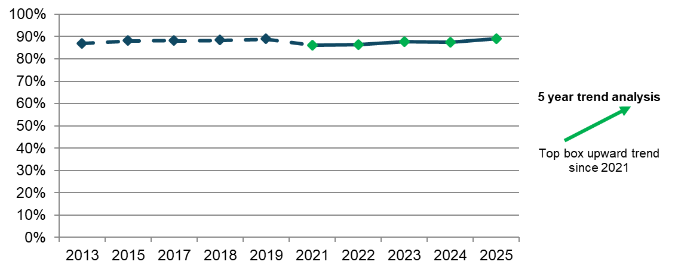
Answered by all. Respondents who stated that they didn't know or couldn't remember have been excluded. Total respondents: (2013) 22,521, (2015) 19,581, (2017) 18,288, (2018) 17,479, (2019) 16,986, (2021) 23,387, (2022) 20,814, (2023) 18,871, (2024) 18,839, (2025) 16,644.

Furthermore, most respondents (81%) reported that they were ‘always’ given enough time to ask questions or discuss their pregnancy, a small statistically significant increase compared with 80% in 2024. Figure 8 shows that there has been a significant upward trend since 2021, where 73% of the respondents said that they had ‘always’ been given enough time to ask questions or discuss their pregnancy.

Figure 8: During your antenatal check-ups, were you given enough time to ask questions or discuss your pregnancy? (% Yes, always)

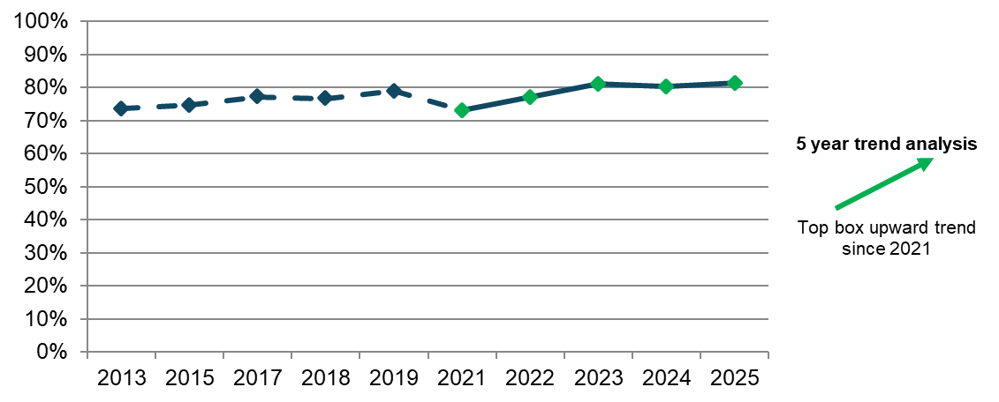
Answered by all. Respondents who stated that they didn't know or couldn't remember have been excluded. Total respondents: (2013) 22,558, (2015) 19,621, (2017) 18,322, (2018) 17,493, (2019) 17,061, (2021) 23,358, (2022) 20,799, (2023) 18,846, (2024) 18,794, (2025) 16, 590.

Likewise, nearly 9 in 10 (88%) respondents answered that they were ‘always’ treated with respect and dignity (figure 9).

Figure 9: Thinking about your antenatal care, were you treated with respect and dignity? By survey year

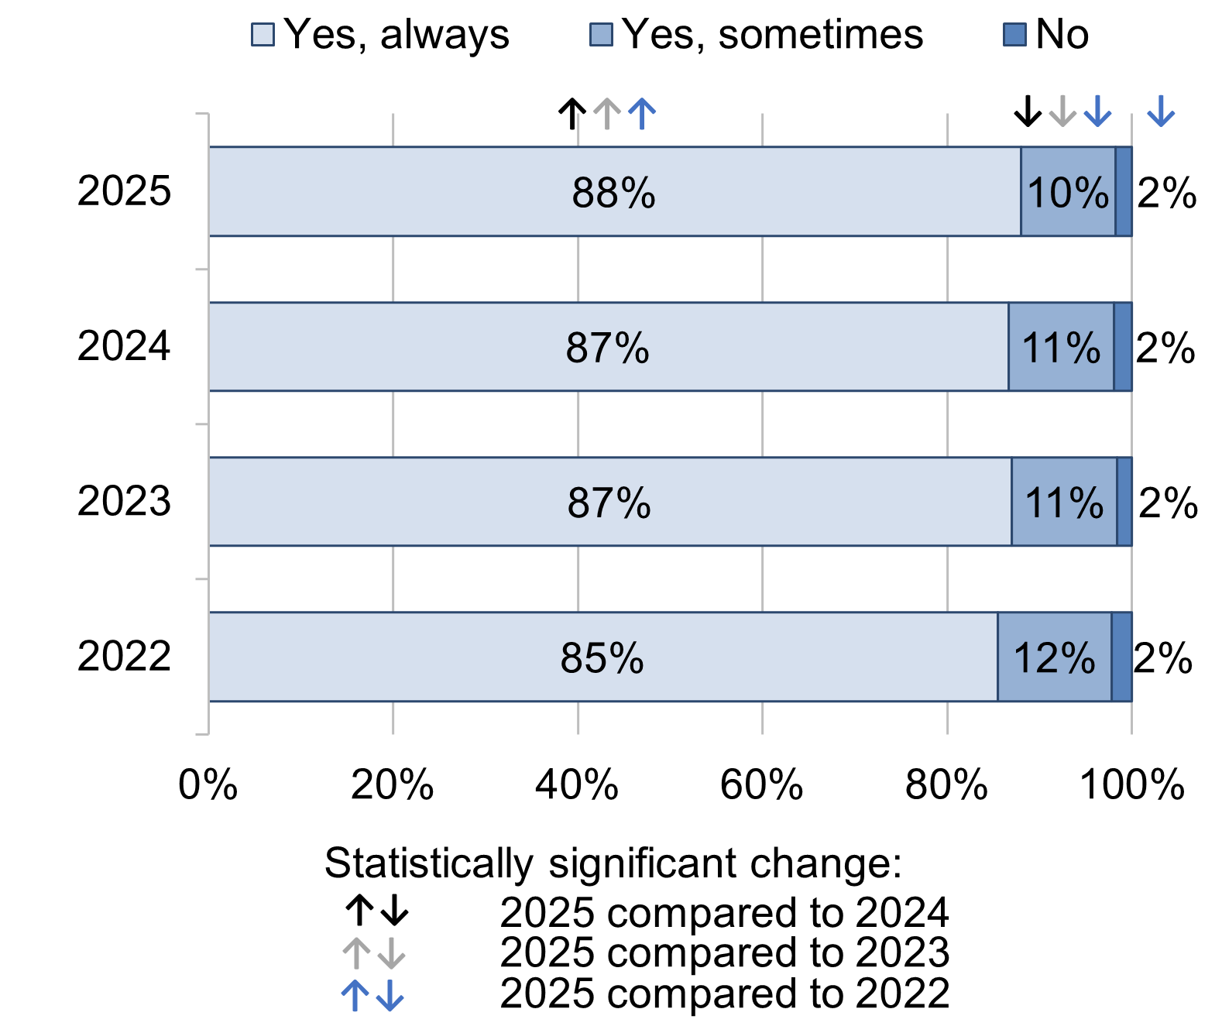

Answered by all. Respondents who stated that they didn't know or couldn't remember have been excluded. Total respondents: (2022) 20,819, (2023) 18,872, (2024) 18,854, (2025) 16,636.
Results of our subgroup analysis for being treated with respect and dignity during antenatal care shows poorer experiences for respondents:
- who had the same midwife 'some of the time’ or 'never' during antenatal care
- who did not have the same midwife during postnatal care
- who did not have continuity of midwives across antenatal care, and labour and birth
- who had an emergency caesarean birth
- aged 16 to 26
- who speak English as their main language
- who live in the most deprived neighbourhoods.

Respondents were also asked whether they felt that any concerns raised during their antenatal care were taken seriously. The majority (88%) of the respondents indicated that their concerns were taken seriously, a small statistically significant increase compared with 87% in 2024. Twelve per cent of the respondents also said that their concerns were not taken seriously, a small statistically significant decrease compared with 13% in 2024 (figure 10).

Figure 10: If you raised a concern during your antenatal care, did you feel that it was taken seriously? By survey year

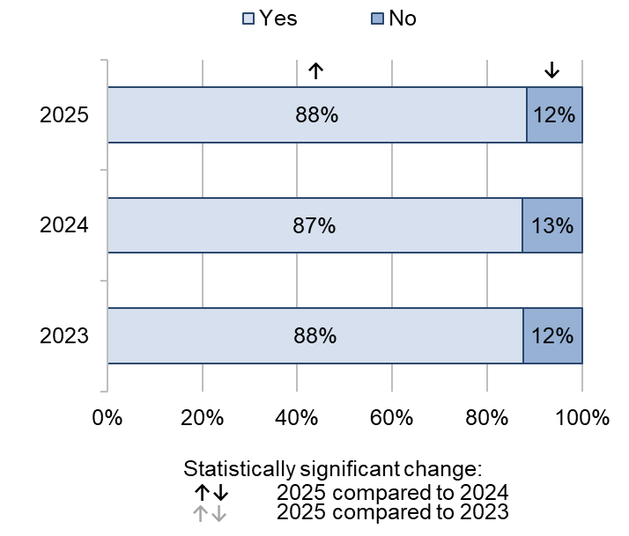

Answered by all. Respondents who stated that they didn't know or couldn't remember have been excluded. Total respondents: (2023) 13,913, (2024) 14,224, (2025) 12,402.

In addition, nearly three-quarters (74%) of the respondents reported ‘always’ being given the help they needed when they contacted their midwifery team, a statistically significant increase compared with 72% in 2024. Meanwhile, a fifth (20%) reported that this happened ‘sometimes’, a statistically significant decrease compared with 23% in 2024. In contrast, 3% reported that this did not happen because they were not able to contact their midwifery team, a small statistically significant increase compared with 2% in 2024. Figure 11 shows that there has been an overall upward trend since 2021 (74% answered ‘yes, always’ in 2025 compared with 70% in 2021).

Figure 11: During your pregnancy, if you contacted a midwifery team, were you given the help you needed? (% Yes, always)
5 year trend analysis

Top box upward trend since 2021

Answered by all. Respondents who stated that they did not contact a midwifery team have been excluded. Total respondents: (2013) 17,953, (2015) 15,665, (2017) 14,997, (2018) 14,263, (2019) 14,207, (2021) 21,424, (2022) 19,178, (2023) 17,328, (2024) 17,250, (2025) 15,047.

Our subgroup analysis for being given the help they needed when contacting the midwifery team during their pregnancy shows poorer than average experiences for respondents:
- who had the same midwife 'some of the time’ or 'never' during antenatal care or postnatal care
- who had the same midwives during antenatal care only, or did not have continuity of midwives across antenatal care, and labour and birth
- aged 16 to 26

Care during labour and birth

There were 10 questions about care during labour and birth that can be analysed over a 5-year period. Five of these show statistically significant improvement since 2021, including questions on people feeling that if they raised a concern during labour and birth these concerns were taken seriously. Meanwhile, the remaining 5 questions show no statistically significant change over the 5-year period, including questions on people being spoken to in a way they could understand, and on having the opportunity to ask questions about their labour and birth after their baby was born.

There were also 17 questions for which 2024 data is available. Of these, 15 questions show a statistically significant positive change in the past year – including those on people being left alone by midwives or doctors at a time when it worried them, on being treated with kindness and compassion, and on their midwives or doctors appearing to be aware of their medical history.

The start of labour

Women giving birth might have concerns about determining when labour has started and the right time to go to the hospital. Health professionals recommend they stay at home until contractions become frequent, therefore it is important that services provide advice and reassurance in early labour about how long they can stay at home.

Just over four-fifths (85%) of the respondents said that they felt that they were given appropriate advice and support when they contacted a midwife or the hospital at the start of their labour. In contrast, 15% said that this did not happen. These results show no statistically significant change compared with 2024 results.

Respondents who went into labour were asked whether they were sent home during labour when they were worried about themselves or their baby. Most (91%) respondents answered that they were not sent home when they were worried about themselves or their baby, a small statistically significant increase compared with 90% in 2024. However, nearly 10% said that this happened at least once (7% ‘this happened once’ and 3% 'this happened more than once’; figure 12).

Figure 12: During your labour, were you ever sent home when you were worried about yourself or your baby? By survey year

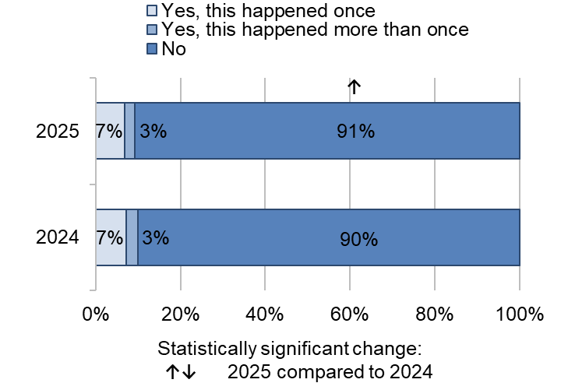

Answered by those who went into labour. Respondents who stated that they didn't know or couldn't remember have been excluded. Total respondents: (2024) 14,302, (2025) 12,266.

Type of delivery

NICE guidance on intrapartum care states that clinical intervention should not be offered or advised if labour is progressing normally, and the mother and baby are well. An instrumental or assisted birth should only be offered if there is concern about the baby's wellbeing, or the woman is experiencing a prolonged second stage labour.

Almost half (43%) of the respondents had unassisted vaginal births (without forceps or ventouse suction cups) – this has seen a statistically significantly decrease compared with 45% in 2024. Planned caesareans increased from 19% in 2024 to 21% in 2025, while emergency caesareans increased from 23% in 2024 to 24% in 2025.

Induced births

NICE guidelines on inducing labour recommend that those with uncomplicated pregnancies should be given every opportunity to go into spontaneous labour. Induction should only be offered to prevent prolonged pregnancy or if there is a risk to the baby or the mother’s health. These guidelines also state that women should be given personalised information to help them make an informed decision about induction.
Almost half (42%) of the respondents said that they had their labour induced – the same as the 2024 result. Of these respondents, just over three-quarters (76%) said that they were given appropriate information and advice on the risks associated with induced labour, a statistically significant increase compared with 74% in 2024. In contrast, nearly a quarter (24%) said that they were not given appropriate information and advice on the risks associated with induced labour, though this has seen a statistically significant decrease compared with 26% in 2024 (figure 13).

Figure 13: Before you were induced, were you given appropriate information and advice on the risks associated with an induced labour? By survey year

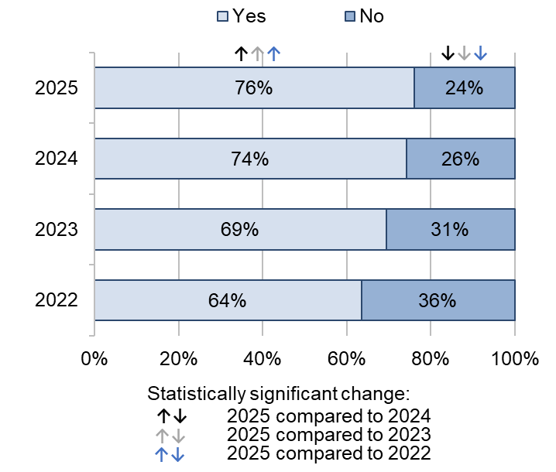

Answered by those who were induced. Respondents who stated that they didn't know or couldn't remember have been excluded. Total number of the respondents: (2022) 6,338, (2023) 5,841, (2024) 5,265, (2025) 4,022.

A new question in the 2025 Maternity survey asked women whose labour was induced whether they were given information about all the options available to them. The majority (79%) of the respondents reported that they were given information about induction of labour (figure 14).

Figure 14: Were you given information about all the options available to you?

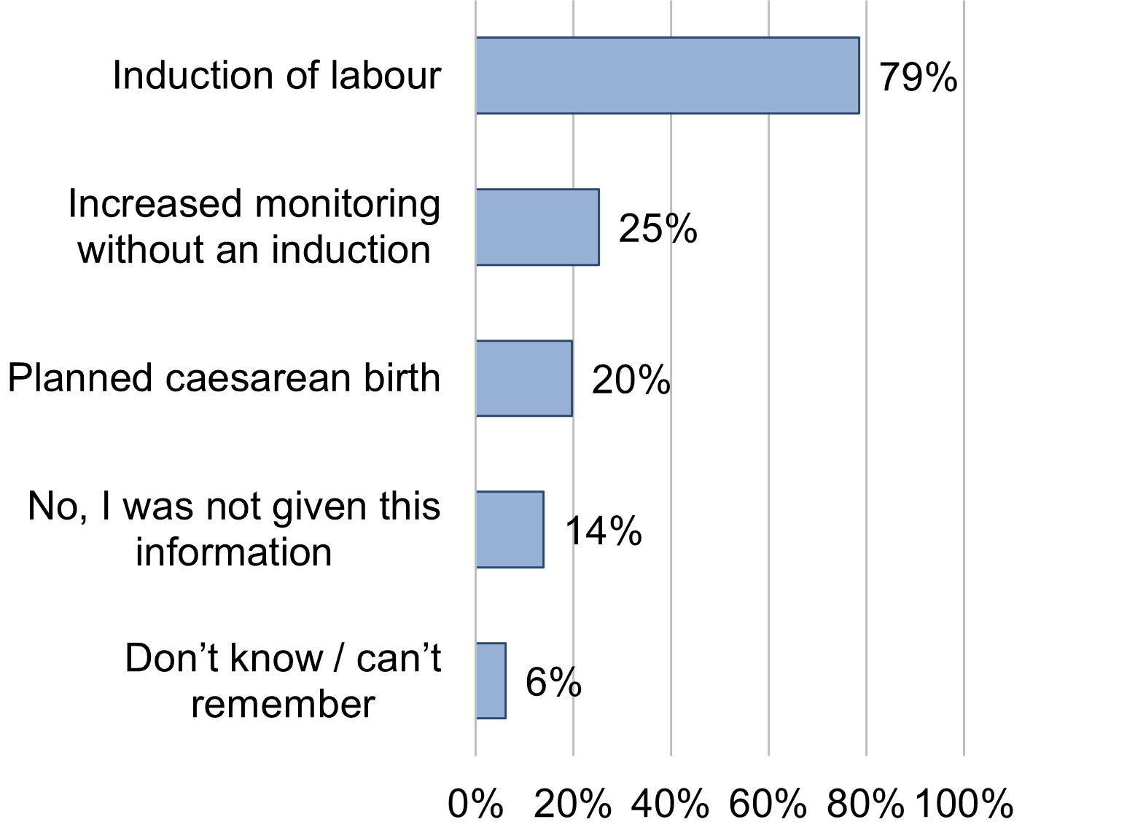

Answered by those who were induced. Multiple response question: percentages might sum to more than 100. Total respondents: (2025) 4,743.

Involvement in decisions

NICE guidance on intrapartum care highlights the importance of ensuring that people feel in control and involved in what is happening to them during childbirth. They should be involved in discussions, and should be able to make informed decisions about their care, including decisions about their birth plan options for managing the stages of labour, and discussions around any tests or interventions.

More than three-quarters (77%) of the respondents said that they were ‘always’ involved in decisions about their care during labour and birth, a significant increase compared with 75% in 2024. Results of our trend analysis show an upward trend since 2021 (75%, figure 15). Conversely, nearly a fifth (18%) said that they were ‘sometimes’ involved, a small statistically significant decrease compared with 19% in 2024. The remaining 5% said that they were not involved in decisions about their care.

Figure 15: Thinking about your care during labour and birth, were you involved in decisions about your care? (% Yes, always)

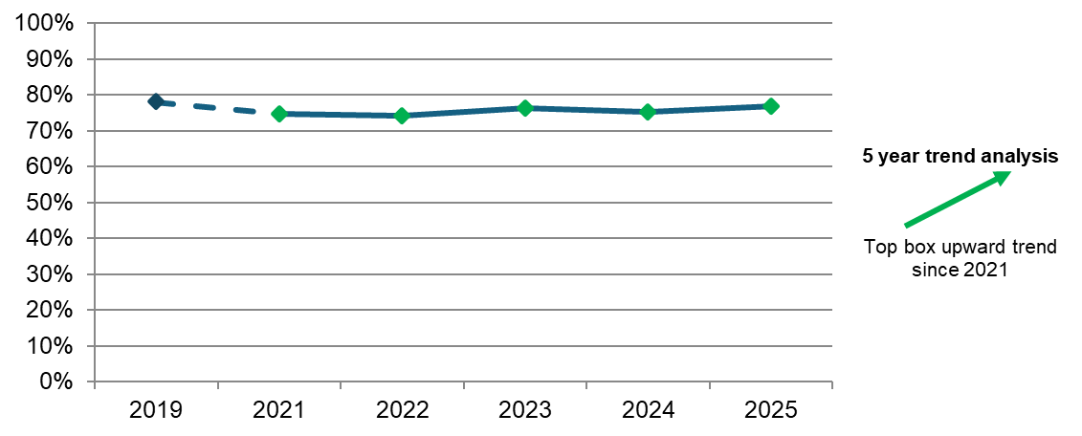
Answered by all. Respondents who stated that they didn't know or couldn't remember or did not want or need to be involved have been excluded. Total respondents: (2019) 16,496, (2021) 22,748, (2022) 20,328, (2023) 18,363, (2024) 18,370, (2025) 16,223.

Results of our subgroup analysis regarding being involved in decisions during labour and birth shows that respondents who did not have the same midwife during their antenatal care or postnatal care reported poorer experiences. Likewise, respondents who did not have continuity of midwives across their antenatal care and labour, and birth also reported poorer experiences. This is also the case for respondents who had an assisted vaginal or emergency caesarean delivery or spoke English as their main language.

Availability of staff

NICE guidance on intrapartum care says that people in established labour should not be left alone except for short periods or on request, and one-to-one midwifery care should be provided. The Royal College of Midwives states that staff shortages might affect trusts’ ability to provide this level of care.

Respondents were asked whether they and/or their partner or a companion were left alone by midwives or doctors at a time when it worried them, to which just over three-quarters (76%) said that they were not, a small statistically significant increase compared with 75% in 2024. In contrast, 7% said that they were left alone at a time when it worried them ‘during the later stages of labour’, while 3% said that this happened ‘during the birth’. A further 9% said that they were left alone ‘shortly after the birth’. Our trend analysis shows no change since 2021 (with 76% answering ’no, not at all’ in 2025, compared with 75% in 2021).

Respondents who had a planned caesarean delivery reported better experiences while respondents who had an assisted vaginal or an emergency caesarean delivery reported poorer experiences. Additionally, respondents who had the same midwife ‘all of the time’ during their antenatal care reported better experiences while respondents who did not have the same midwife during their antenatal care reported poorer experiences. This was also the case for age, with respondents in the group aged 33 or over reporting better experiences and respondents who were younger (aged 16 to 26) reporting poorer experiences.

In addition, respondents were asked whether, during labour and birth, they were able to get a member of staff to help them when they needed it. Results show that two-thirds (66%) of the respondents were ‘always’ able to get this help, while 12% answered that a member of staff was with them ‘all the time’. The proportion of respondents who answered that they were ‘always’ able to get this help has seen a significant increase compared with that in 2024 (64%). Conversely, nearly a fifth (18%) answered that they were ‘sometimes’ able to get this help, a small statistically significant decrease compared with 19% in 2024. The remaining 5% answered that they were not able to get this help (figure 16).

Figure 16: During labour and birth, were you able to get a member of staff to help you when you needed it? By survey year

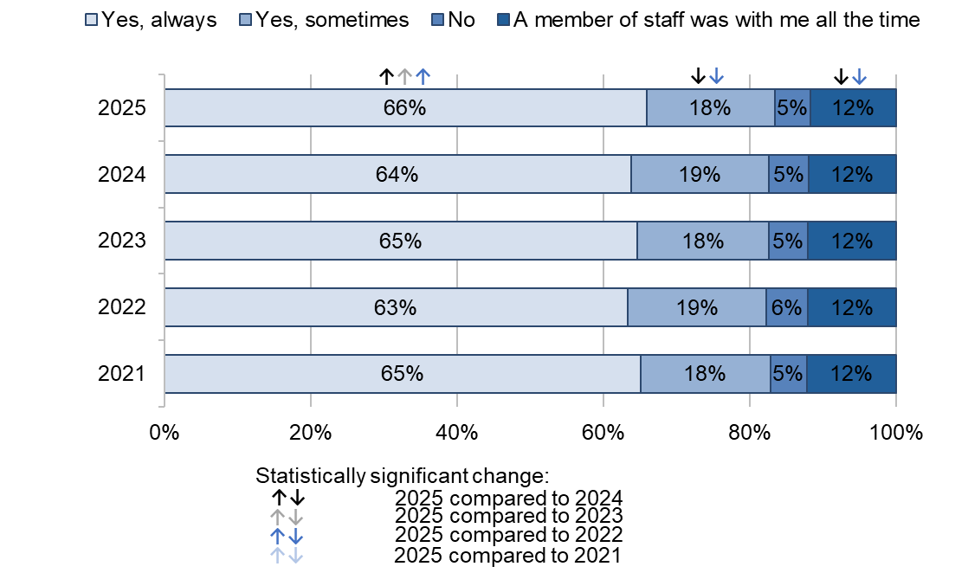

Answered by all. Respondents who stated that they didn't know or couldn't remember or did not want or need this have been excluded. Total number of the respondents: (2021) 22,572, (2022) 20,069, (2023) 18,216, (2024) 18,284, (2025) 16,158.
Results of our subgroup analysis regarding being able to get help when needed during labour and birth shows poorer experiences for respondents:

- who had the same midwife 'some of the time’ or 'never' during antenatal care or postnatal care
- who had an emergency caesarean birth
- aged 16 to 26
- who speak English as their main language.

Communication and compassionate care

NICE guidance on patient experience states that all healthcare professionals directly involved in a patient's care should introduce themselves. As labour and birth can last for a long time, there might be handovers of care between different health professionals (for example, because of shift changes) requiring them to introduce themselves to the woman in labour.

The majority (84%) of the respondents said that ‘all of the staff’ treating and examining them introduced themselves, a small statistically significant increase compared with 83% in 2024. A total of 14% said, ‘some of the staff introduced themselves’, which is a small statistically significant decrease compared with 15% in 2024. Figure 17 shows an overall upward trend since 2021 (with 84% answering ‘Yes, all of the staff introduced themselves’ in 2025 compared with 80% in 2021), which we discovered as part of our trend analysis.

Figure 17: Did the staff treating and examining you introduce themselves? (% Yes, all of the staff introduced themselves)

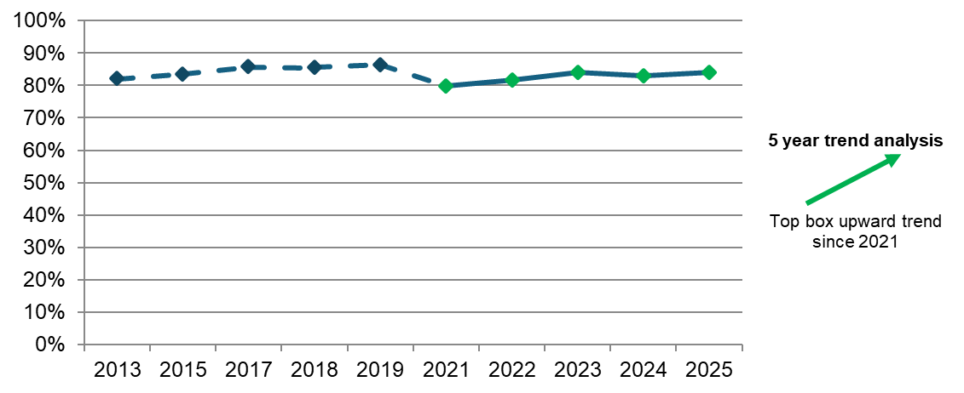
Answered by all. Respondents who stated that they didn't know or couldn't remember have been excluded. Total respondents: (2013) 22,119, (2015) 19,258, (2017) 17,965, (2018) 17,089, (2019) 16,745, (2021) 23,040, (2022) 20,487, (2023) 18,552, (2024) 18,583, (2025) 16,404.

NHS England’s three year delivery plan sets out that maternity care should include open and honest, ongoing dialogue between women, their midwife, and other clinicians to understand the care that people want and any concerns they might have, and to discuss any outcomes that are not as expected. The Care Quality Commission’s (CQC) National review of maternity services in England 2022 to 2024 reported that clear and transparent language and explanations help women to know what to expect from procedures and examinations and to make informed choices.

The majority (86%) of the respondents answered that they were ‘always’ spoken to in a way that they could understand during labour and birth (compared with 85% in 2024), while 11% said that this happened ‘sometimes’ (compared with 12% in 2024). The remaining 2% said that this did not happen, compared with 3% in 2024. Meanwhile, trend analysis indicates no change since 2021 (with 86% answering ‘yes, always’ in 2021).

In comparison, respondents were asked whether they had the opportunity to ask questions about their labour and birth after their baby was born, to which just over half (51%) said ‘yes, completely’. Just over a quarter (26%) said that they had the opportunity ‘to some extent’, while a further 23% said that they did not have this opportunity. The results of our trend analysis indicate no change since 2021 (with 50% answering ‘yes, completely’ in 2021).

NICE guidance on patient experience states that patients must be treated with kindness, compassion, understanding, courtesy, and honesty. Compassionate care is at the heart of safe and high-quality maternity care where all voices are listened to and respected.

Most (83%) of the respondents answered that they were ‘always’ treated with kindness and compassion during their labour and birth (compared with 82% in 2024). Meanwhile, 14% answered that they were ‘sometimes’ treated with kindness and compassion (compared with 15% in 2024) (figure 18).

Figure 18: Thinking about your care during labour and birth, were you treated with kindness and compassion? By survey year

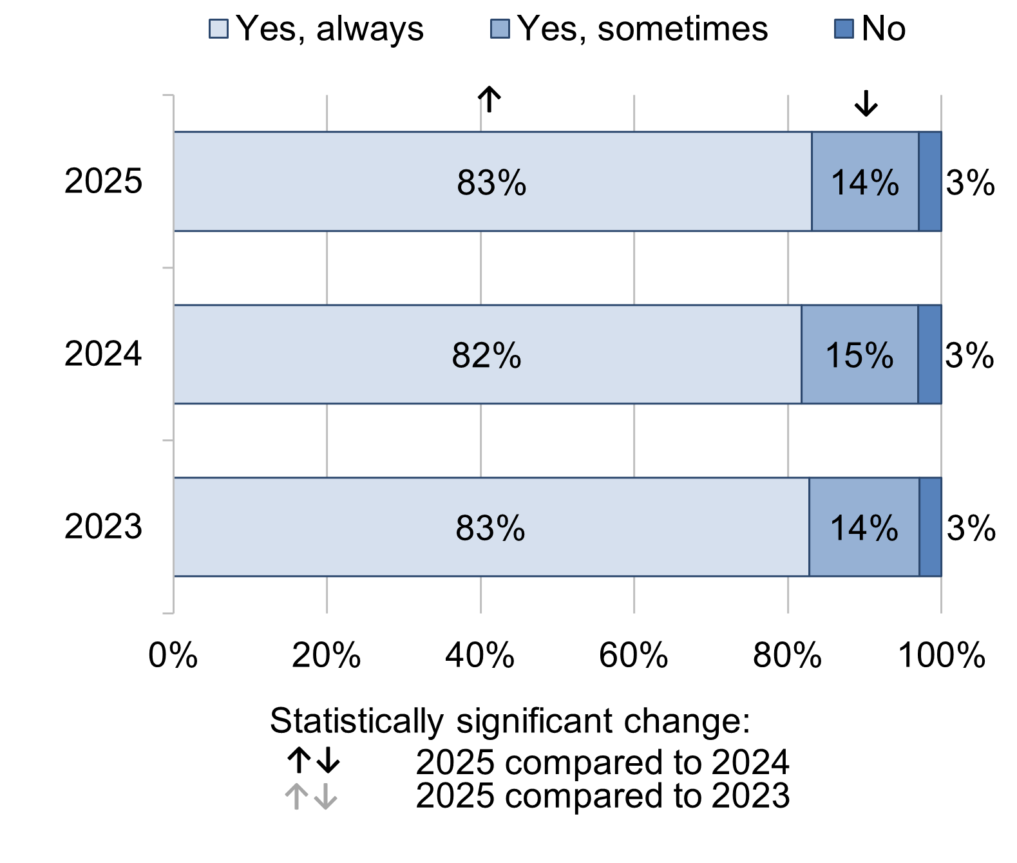
Answered by all. Respondents who stated that they didn't know or couldn't remember have been excluded. Total number of the respondents: (2023) 18,812, (2024) 18,793, (2025) 16,620.

Results of our subgroup analysis for being treated with kindness and compassion during labour and birth shows that respondents who had the same midwife ‘all of the time’ or ‘most of the time’ during antenatal care reported better experiences, while respondents who did not have the same midwife during antenatal care reported poorer experiences. Similarly, those who had the same midwife ‘all of the time’ during postnatal care reported better experiences, while those who had the same midwife ‘some of the time’ or ‘never’ during postnatal care reported poorer experiences. Other groups who reported poorer experiences include those:
- who were aged 16 to 26
- who speak English as their main language
- who had an assisted vaginal or an emergency caesarean delivery.

Of those respondents who raised a concern during labour and birth, most (82%) felt that their concerns were taken seriously. In contrast, nearly a fifth (18%) said that they felt that their concerns were not taken seriously. Results remain in line with the results in 2024. Figure 19 shows that there has been a significant upward trend since 2021 (with 82% answering ‘Yes’ in 2025 compared with 79% in 2021).

Figure 19: If you raised a concern during labour and birth, did you feel that it was taken seriously? (% Yes)

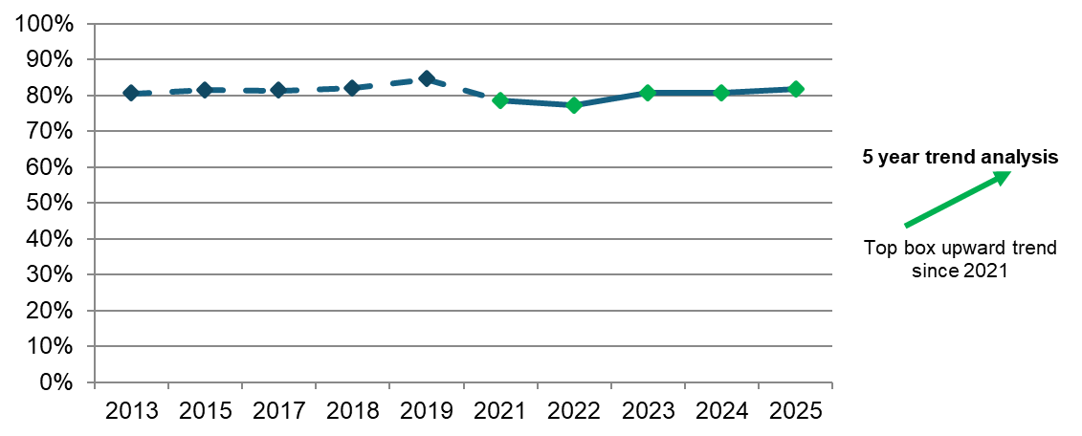
Answered by all. Respondents who stated that they did not raise any concerns have been excluded. Total respondents: (2013) 13,660, (2015) 12,358, (2017) 11,233, (2018) 10,709, (2019) 10,633, (2021) 14,816, (2022) 13,350, (2023) 12,718, (2024) 12,883, (2025) 11,402.
Respondents who had an assisted vaginal or emergency caesarean delivery reported poorer experiences when they raised a concern, whereas women who had a planned caesarean delivery reported better experiences. Additionally, respondents who did not have the same midwife during antenatal care also reported poorer experiences, while respondents who had the same midwife ‘all of the time’ reported better experiences. Likewise, respondents who did not have the same midwife during postnatal care reported poorer experiences, while respondents who had the same midwife ‘all of the time’ or ‘some of the time’ reported better experiences. Respondents who spoke English as their main language also reported poorer experiences when they raised a concern.

Pain management

CQC’s National Maternity Inspection Programme report for 2024 identifies pain management during labour and birth as an issue nationally. The findings from the programme show that most trusts did not audit women’s outcomes and experiences of pain and pain relief.

Women were asked whether they thought their healthcare professionals did everything they could to help manage pain during labour and birth. Over half (65%) answered that they ‘definitely’ did and 23% said that they did ‘to some extent’, while 13% said ‘no’ (figure 20).

Figure 20: Do you think your healthcare professionals did everything they could to help manage your pain during labour and birth? By survey year

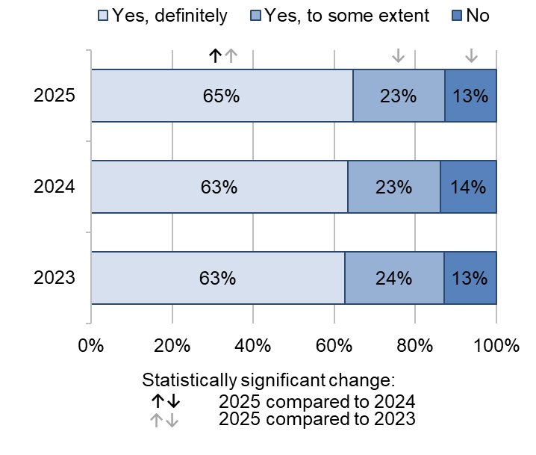
Answered by those who had a labour. Respondents who stated that they didn't know or couldn't remember or did not need any help with pain relief have been excluded. Total number of the respondents: (2023) 13,884, (2024) 13,677, (2025) 11,730.

Of those who said that that their healthcare professionals ‘definitely’ did everything they could to help manage pain during labour, most (94%) respondents said that they were ‘always’ treated with kindness and compassion during their labour and birth. In contrast, of those who said that their healthcare professionals did not do everything they could to help manage pain during labour and birth, nearly a fifth (18%) said that they were not treated with kindness and compassion during their labour and birth (figure 21).

Figure 21: Cross-tabulation of C8 (Do you think your healthcare professionals did everything they could to help manage your pain during labour and birth? [Yes, definitely/Yes, to some extent/No]) by C21 (Thinking about your care during labour and birth, were you treated with kindness and compassion? [Yes, always/Yes, sometimes/No])

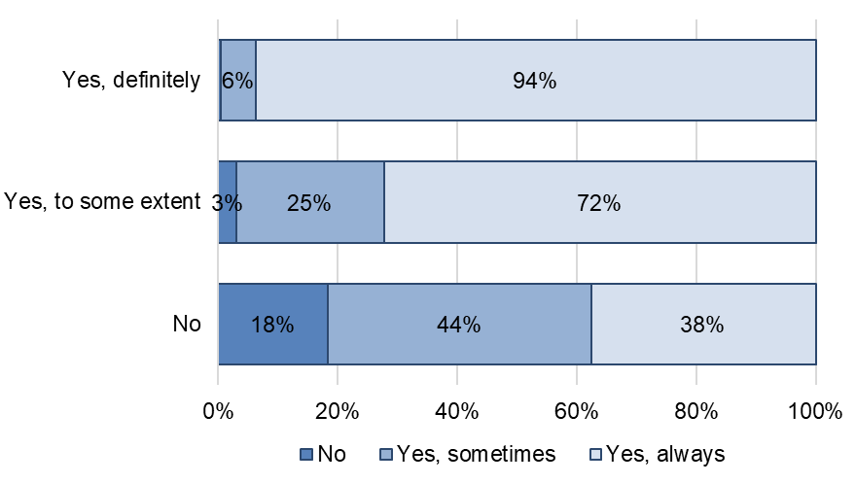
Answered by those who had a labour. Respondents who stated that they didn't know or couldn't remember have been excluded. Respondents who stated that they did not need any help with pain relief have been excluded from c8. Total number of the respondents: (Yes, definitely) 7,549, (Yes, to some extent) 2,638, (No) 1446.

Results of our subgroup analysis for pain management during labour and birth show that respondents who did not have the same midwife during their antenatal care, or who had the same midwife ‘some of the time’ or ‘never’ during their postnatal care, reported poorer experiences. This is also the case for respondents who gave birth for the first time.

Teamworking

CQC’s National review of maternity services in England 2022 to 2024 highlights the importance of culture in maternity services in terms of positive working relationships within multidisciplinary teams. The report states that good communication between staff is essential to ensuring awareness of potential risks and delivery of compassionate care.

Respondents were asked whether they felt that the midwives and/or doctors looking after them during labour and birth worked well together. More than three-quarters (77%) of the respondents said that the midwives and/or doctors ‘always’ worked well together, a significant increase compared with 74% in 2024. (figure 22).

Figure 22: Thinking about your care during labour and birth, did you feel that the midwives and / or doctors looking after you worked well together? By survey year

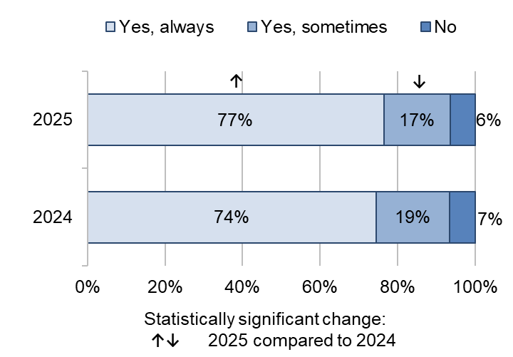

Answered by all. Respondents who stated that they didn't know or couldn't remember have been excluded. Total respondents: (2024) 18,645, (2025) 16,443.

Postnatal care in hospital

There were 5 questions about care in hospital after the birth that can be analysed over a 5-year period. Two of these – those on people being treated with kindness and understanding, and on their partner or someone else close being able to stay as much as the woman wanted – show statistically significant improvement since 2021.

There were 6 questions for which comparison with 2024 data is available. Of these, all 6 questions show positive change in the past year – including healthcare professionals doing everything they could to help manage pain.

Length of stay and discharge

NICE clinical guidelines on postnatal care suggest that there is no optimal postpartum length of stay but recommend decisions around this should take into account the health of both mothers and their babies, and the level of support available after discharge.

Respondents were also asked whether their discharge on the day they left hospital was delayed. Just over a third (37%) of the respondents reported delays in their discharge from hospital, a statistically significant decrease compared with 40% in 2024. Our trend analysis indicates no change since 2021.

Information

Recommendations from CQC’s National review of maternity services in England 2022 to 2024 outline that women should be provided information following labour and birth to help them process what happened, including when a safety incident takes place, in order to inform decisions about future pregnancies.

Just under two-thirds (61%) of the respondents said that they were ‘always’ given the information or explanation they needed during their care in hospital after the birth of their baby, which is a statistically significant increase compared with 58% in 2024. Meanwhile, 11% said that they were not given this information, which is a statistically significant decrease compared with 13% in 2024. Our trend analysis indicates no statistically significant change since 2021.

Our subgroup analysis of respondents being given the information or explanation they needed during their care in hospital after the birth of their baby shows poorer experiences for some groups, including respondents:
- who did not have the same midwife during antenatal care
- who had the same midwife ‘some of the time’ or ‘never’ during postnatal care
- who did not have continuity of midwives across antenatal care, and labour and birth
- who gave birth for the first time during their most recent pregnancy
- who had an emergency caesarean birth
- who speak English as their main language.

Kindness and understanding

Nearly three-quarters (73%) of the respondents reported ‘always’ being treated with kindness and understanding in hospital after the birth of their baby, a statistically significant increase compared with 71% in 2024. Meanwhile, just over a fifth (21%) reported that this happened ‘sometimes’, a statistically significant decrease compared with 23% in 2024. Figure 23 shows that there has been an overall upward trend since 2021 (with 71% answering ‘Yes, always’ to the same question in 2021).

Figure 23: Thinking about the care you received in hospital after the birth of your baby, were you treated with kindness and understanding?

(% Yes, always)

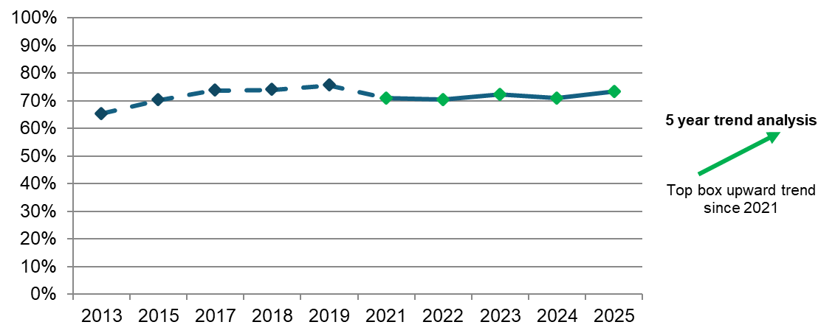
Answered by those who stayed in hospital after the birth or required hospital care after a home birth.
Respondents who stated that they didn't know or couldn't remember have been excluded. Total number of the respondents: (2013) 22,113, (2015) 19,249, (2017) 17,979, (2018) 16,985, (2019) 16,595, (2021) 22,921, (2022) 20,552, (2023) 18,545, (2024) 18,554, (2025) 16,410.

Results of our subgroup analysis for being treated with kindness and understanding in hospital after the birth shows poorer experiences for respondents:
- who had the same midwife ‘some of the time’ or ‘never’ during antenatal care or postnatal care
- who had an emergency caesarean birth
- who did not have continuity of midwives across antenatal care, and labour and birth
- who gave birth for the first time during their most recent pregnancy
- who speak English as their main language.

Availability of staff

More than half (57%) of the respondents said that they were ‘always’ able to get a member of staff to help them while in hospital after the birth (compared with 54% in 2024). However, 10% said that they were not able to get this help (compared with 12% in 2024). Our trend analysis indicates no change since 2021.

Of those who said that they were ‘always’ able to get a member of staff to help them while in hospital after the birth, the majority (86%) of the respondents said that their healthcare professionals ‘definitely’ did everything they could to help manage pain in hospital after the birth. In contrast, of those who said that they were not able to get a member of staff to help them while in hospital after the birth, more than half (54%) said that their healthcare professionals did not do everything they could to help manage pain during labour and birth (figure 24).

Figure 24: Cross-tabulation of D3 (If you needed attention while you were in hospital after the birth, were you able to get a member of staff to help you when you needed it?[Yes, always/Yes, sometimes/No]) by D7 (Do you think your healthcare professionals did everything they could to help manage your pain in hospital after the birth?[Yes, definitely/Yes, to some extent/No])

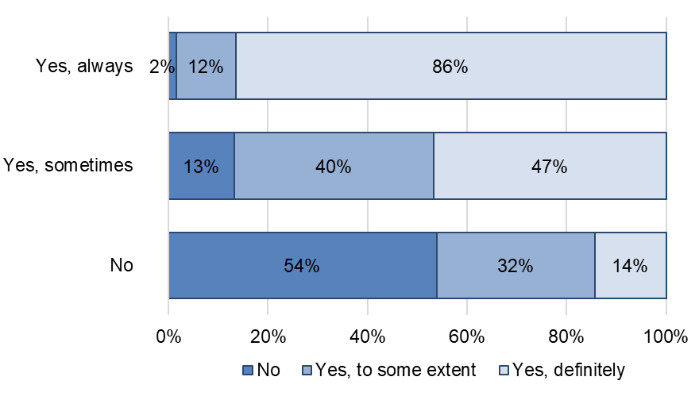

Answered by those who stayed in hospital after the birth or required hospital care after a home birth. Respondents who stated that they didn't know or couldn't remember have been excluded. Respondents who stated that they did not want or need this have been excluded from d3. Respondents who stated that they didn't need any help with pain relief have been excluded from d7. Total number of the respondents: (Yes, always) 8,398, (Yes, sometimes) 4,924, (No) 14,24.

Results of our subgroup analysis shows poorer experiences for respondents:
- who did not have the same midwife during antenatal care
- who had an assisted vaginal or emergency caesarean birth
- who had the same midwife ‘some of the time’ or ‘never’ during postnatal care
- who did not have continuity of midwives across antenatal care, and labour and birth
- who speak English as their main language
- who reported their religion as Jewish.

Partner involvement

Almost three-quarters (72%) of the respondents said that their partner or someone else close to them was able to stay as much as they wanted to in hospital after the birth, a statistically significant increase of 9 percentage points compared with 2024 (63%). Conversely, just under a fifth (19%) said that their partner or someone else close to them was not able to stay as much as they wanted to ‘as they were restricted to visiting hours’, a statistically significant decrease of 9 percentage points compared with 2024 (28%). Figure 25 shows an overall upward trend, from 33% answering ‘Yes’ always’ in 2021 to 72% in 2025, which we found from the results of our trend analysis.

Figure 25: Thinking about your stay in hospital, if your partner or someone else close to you was involved in your care, were they able to stay with you as much as you wanted? (% Yes, always)

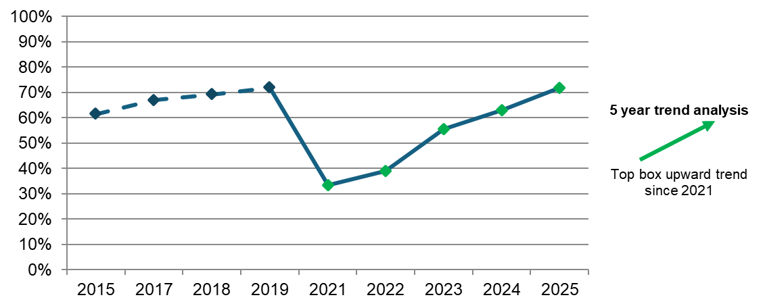
Total respondents: (2021) 16,500, (2022) 18,967, (2023) 18,561, (2024) 18,603, (2025) 16,431.

Pain Management

Figure 26 shows that when asked whether they thought healthcare professionals did everything they could to help manage pain in hospital after birth, two-thirds (66%) of the respondents answered ‘definitely’, a statistically significant increase compared with 64% in 2024. However, 10% of respondents said ‘no’, a statistically significant decrease compared with 12% in 2024.

Figure 26: Do you think your healthcare professionals did everything they could to help manage your pain in hospital after the birth? By survey year

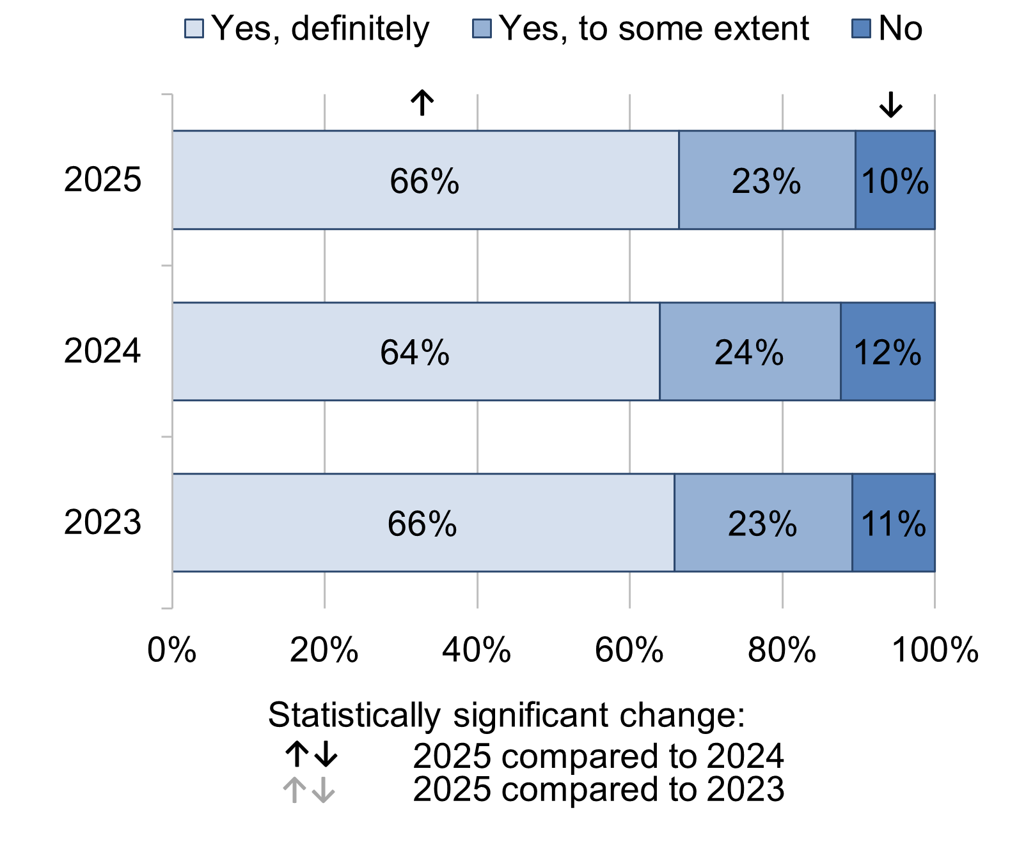
Answered by those who stayed in hospital after the birth or required hospital care after a home birth. Respondents who stated that they didn't need any help with pain relief or didn't know or couldn't remember have been excluded. Total number of the respondents: (2023) 17,213, (2024) 17,423, (2025) 15,412.

Results of our subgroup analysis for pain management in hospital after the birth shows poorer experiences for respondents:
- who did not have the same midwife during their antenatal care or their postnatal care
- who did not have continuity of midwives across antenatal care, and labour and birth
- who had planned or emergency caesarean deliveries
- who speak English as their main language
- with pelvic health problems.

Postnatal care at home

There were 11 questions about postnatal care after leaving hospital that can be analysed over a 5-year period. Seven of these – including those on people being given information about their own physical recovery after the birth, and on their midwife or midwifery team appearing to be aware of theirs or their baby’s medical history – show statistically significant improvement since 2021. Conversely, the remaining 4 questions indicate no change over a 5-year period – including those respondents feeling that their midwife or midwifery team listened to them.

In comparison with 2025, there were 18 questions for which we have 2024 data. Of these, 16 questions show a statistically significant improvement in the past year – including those on people being able to get support or advice about feeding their baby if they needed this during evenings, night or weekends.

Postnatal appointments

NICE guidance on postnatal care suggests a minimum of 3 contacts with women and their baby. Postnatal care should be provided face-to-face and supplemented by virtual discussions and written formats.

Just under two-thirds (61%) of the respondents said that they saw or spoke to a midwife as much as they wanted to, a small statistically significant increase compared with 60% in 2024. Meanwhile, a third (33%) said that they would have liked this ‘more often’ – this has seen a small statistically significant decrease compared with 34% in 2024. The remaining 6% said that they would have like this ‘less often’, consistent with the results in 2024. Our trend analysis indicates no change since 2021.

Results of our subgroup analysis regarding speaking to a midwife as much as women wanted to during postnatal care shows poorer than average experiences for respondents:
- aged 16 to 26
- who did not speak English as their main language
- who gave birth for the first time during their most recent pregnancy
- who did not have the same midwife during their postnatal care.

Information

NICE guidance on postnatal care recommends that healthcare professionals should provide information, reassurance, and further care, including information on:

- what to expect during the postnatal period
- potential physical problems and the knowledge of how to seek help for them
- the importance of pelvic floor exercises and the knowledge of when to seek help for them.

Just over half (51%) of the respondents reported ‘definitely’ being given information about their physical recovery after birth – this has seen a statistically significant increase compared with 48% in 2024. Just over a third (35%) reported being given this information ‘to some extent’, which is a statistically significant decrease compared with 37% in 2024. However, 14% reported not being given this information, a small statistically significant decrease compared with 15% in 2024. Results of our trend analysis show an upward trend since 2021 (47%; figure 27).

Figure 27: Were you given information about your own physical recovery after the birth? (% Yes, definitely)

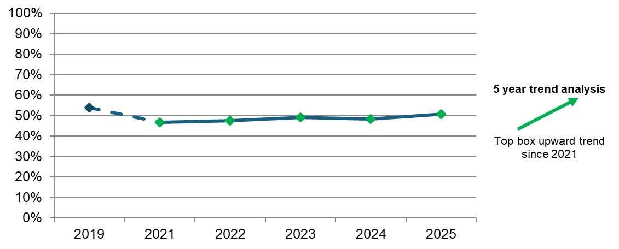
Answered by all. Respondents who stated that they didn't know or couldn't remember or did not need this information have been excluded. Total respondents: (2021) 22,568, (2022) 20,127, (2023) 18,222, (2024) 18,131, (2025) 16,075.

Communication and compassionate care

NICE guidance on postnatal care recommends that healthcare professionals should listen to women and their needs and preferences. Women with complex social considerations might need additional support, including improved access to care, continued contact with healthcare professionals, and additional information relevant to their personal circumstances.

More than three-quarters (77%) of the respondents said that their midwife or midwifery team ‘always’ listened to them, a statistically significant increase compared with 75% in 2024. Almost a fifth (19%) said that they ‘sometimes’ felt listened to, a statistically significant decrease compared with 21% in 2024. In contrast, 4% said that they were not listened to. Our trend analysis indicates no change since 2021 (with 76% answering ‘yes, always’ to the same question in 2021).
Results of our subgroup analysis for midwives listening to women during their postnatal care shows poorer experiences for respondents:
- who did not have the same midwife during their antenatal care or their postnatal care
- who did not have the continuity of midwives across their antenatal care, and their labour and birth
- who had a planned or emergency caesarean birth
- who spoke English as their main language.

Meanwhile, respondents who reported their religion as Christian reported better than average experiences of their midwives listening to them during postnatal care.

In addition, three-quarters (75%) of the respondents said that their midwife or midwifery team ‘always’ took their personal circumstances into account when giving them advice, a statistically significant increase compared with 2024 (72%). Conversely, a fifth (20%) said that their midwife or midwifery team ‘sometimes’ took their personal circumstances into account, a statistically significant decrease compared with 2024 (22%). The remaining 6% said their midwife or midwifery team did not take their personal circumstances into account. Our trend analysis indicates no change since 2021.

Likewise, three-quarters (75%) of the respondents reported ‘always’ being given the help they needed if they contacted a midwife or a midwifery team, a statistically significant increase compared with 71% in 2024. Meanwhile, a fifth (20%) reported ‘sometimes’ being given the help they needed, a statistically significant decrease compared with 23% in 2024. However, 5% reported not being given the help they needed – this has seen a small statistically significant decrease compared with 6% in 2024 (figure 28).

Figure 28: If you contacted a midwife / midwifery team, were you given the help you needed? By survey year

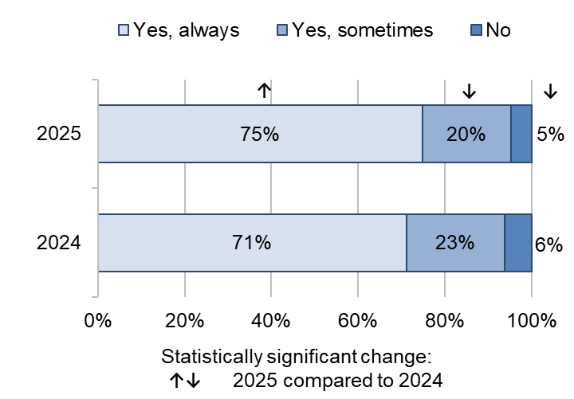

Answered by all. Respondents who stated that they did not contact a midwife or midwifery team have been excluded. Total number of the respondents: (2024) 15,728, (2025) 13,701.

Results of our subgroup analysis shows that respondents who did not have the same midwife during their antenatal care or their postnatal care reported poorer than average experiences of being given the help they needed after leaving hospital. Similarly, respondents who did not have continuity of midwives across antenatal care and labour and birth or who had a planned or emergency caesarean delivery also reported poorer than average experiences.

In comparison, nearly two-thirds (65%) said that they ’definitely’ received help and advice from midwives about their baby’s health and progress in the 4 weeks after the birth, a statistically significant increase compared with 62% in 2024. More than a quarter (27%) said that they received this help and advice ‘to some extent’, a statistically significant decrease compared with 29% in 2024. (figure 29).

Figure 29: In the four weeks after the birth of your baby, did you receive help and advice from midwives about your baby’s health and progress? By survey year

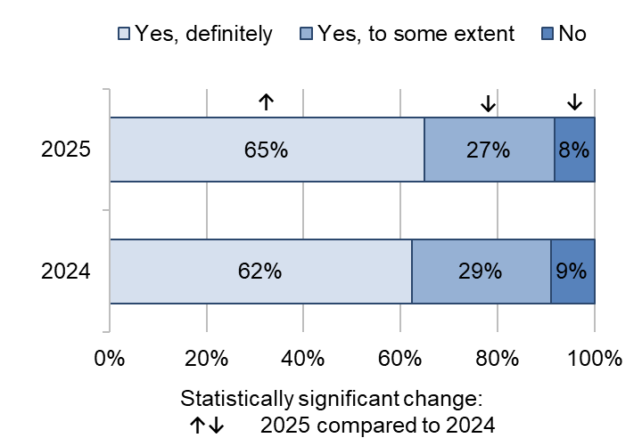

Answered by all. Respondents who stated that they didn't know or couldn't remember or didn't need any help and advice have been excluded. Total respondents: (2024) 16,596, (2025) 14,710.

Involvement in decisions

Respondents were asked whether they were involved in decisions about their postnatal care. Three-quarters (75%) of the respondents reported that they were ‘always’ involved, a statistically significant increase compared with 72% in 2024. (figure 30).

Figure 30: Thinking about your postnatal care, were you involved in decisions about your care? By survey year

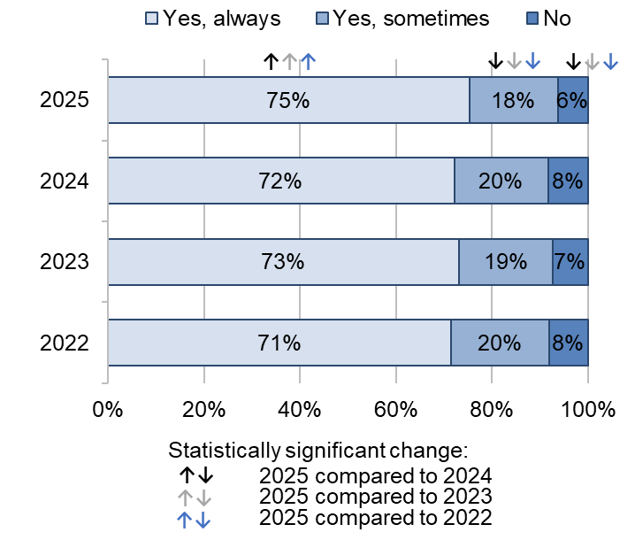

Answered by all. Respondents who stated that they didn't know or couldn't remember or did not want or need to be involved have been excluded. Total number of the respondents: (2022) 19,947, (2023) 18,009, (2024) 17,924, (2025) 15,774.

Results of our subgroup analysis regarding being involved in decision during postnatal care shows poorer experience for respondents:
- who had the same midwife 'some of the time’ or 'never' during antenatal care or postnatal care
- who did not have continuity of midwives across antenatal care and labour and birth
- who had a planned or emergency caesarean delivery
- who gave birth for the first time during their most recent pregnancy
- with a pregnancy-related condition (that does not include pelvic health problems).

Triage

As noted in CQC’s National review of maternity services in England 2022 to 2024, maternity triage is an important first step to get advice, assessment and risk prioritisation for women who have an emergency or concern during their pregnancy, early labour, or in the post-birth period. This could include advising women to go to their chosen birthing unit because they are in labour, suggesting a call back for further review, or making sure women are seen urgently if they have an obstetric issue that needs assessment, such as bleeding or if they have reduced foetal movements.

Seventy-seven per cent of the respondents said that they went through triage at any point during their pregnancy or postnatal care to have their symptoms assessed, either by telephone or face-to-face.

For the first time in the Maternity survey, respondents were asked whether they felt that they had gotten the advice they needed when they contacted the telephone triage line. Nearly three-quarters (72%) of the respondents answered that they ‘definitely’ got the advice they needed, while just over a fifth (21%) answered that they got the advice they needed ‘to some extent’, 6% answered that they did not get the advice they needed, and 2% answered that ‘they tried to call but were unable to speak to someone’ (figure 31).

Figure 31: Thinking about the last time you contacted the telephone triage line, did you feel that you got the advice you needed?
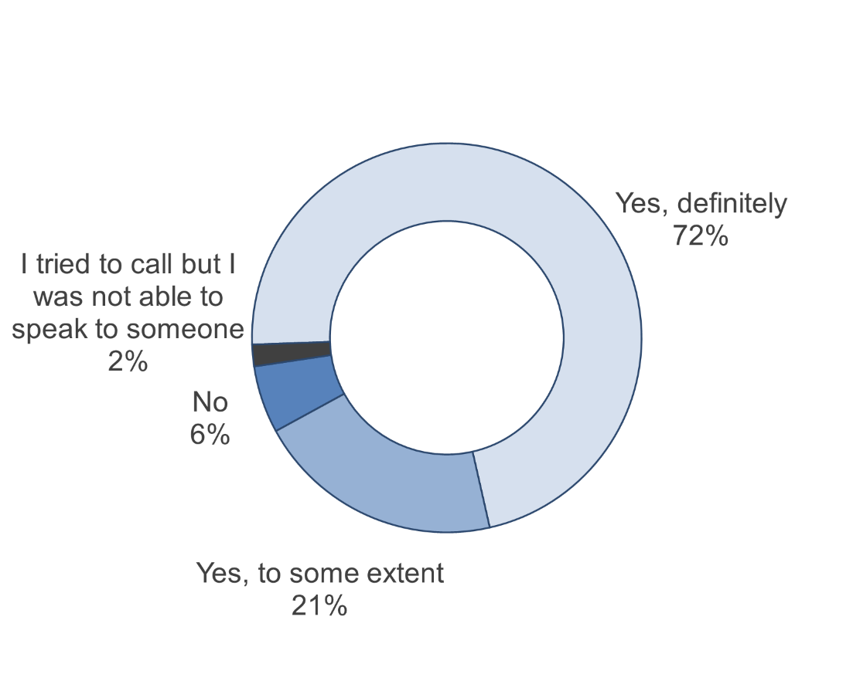
Answered by those who went through triage to have their symptoms assessed at any point during their pregnancy or postnatal care. Respondents who did not contact the telephone triage line or didn't know or couldn't remember have been excluded. Total respondents: (2025) 11,243.

The Royal College of Obstetricians & Gynaecologists’ Good Practice Paper on Maternity Triage recommends that a brief initial assessment and prioritisation of urgency should take place with a midwife trained in a specific triage method within 15 minutes of the service user attending the maternity triage unit.

For the first time in the Maternity survey, of those who attended triage face-to-face, respondents were asked how they felt about the length of time they waited before they were seen by a midwife during the last time they attended triage. More than half (53%) said that ‘they had to wait, but not for too long’. Results also show that:
- 23% said that they ‘did not have to wait’
- 14% said that they ‘had to wait a bit too long’
- 9% said that they ‘had to wait far too long'.

For the first time in the Maternity survey, respondents were also asked whether the midwife or doctor they spoke to listened to them when they attended triage face-to-face. The majority (78%) of the respondents reported that their midwife or doctor ‘definitely’ listened to them, while 17% reported that this happened ‘to some extent’, and 5% reported that this did not happen.

Midwifery continuity of carer

Care from the same midwife across phases of maternity is associated with better outcomes for mother and baby. Implementing midwifery continuity of carer is a key part of NHS England’s three-year delivery plan to address health inequalities for women who might need additional support, particularly for women from ethnic minority backgrounds and women living in the most deprived areas.

A quarter (25%) of the respondents indicated that they saw or spoke to the same midwife ‘all of the time’ at their antenatal check-ups, a small statistically significant increase compared with 24% in 2024. Fifteen per cent indicated that they saw or spoke to ‘a different midwife every time’ (figure 32).

Figure 32: At your antenatal check-ups, how often did you see or speak to the same midwife? By survey year

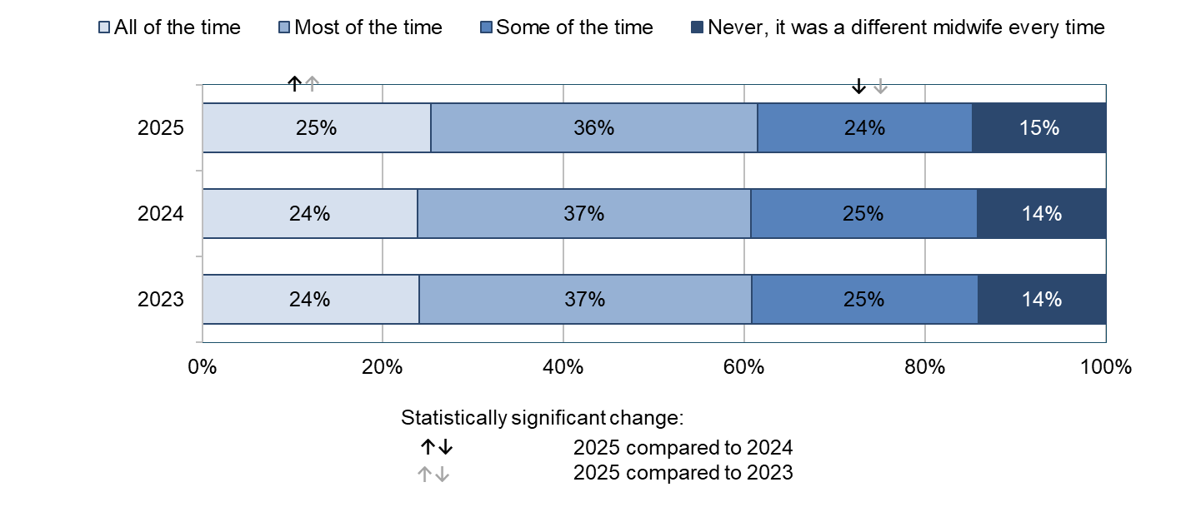
Answered by all. Respondents who stated that they didn't know or couldn't remember or did not see or speak to a midwife have been excluded. Total respondents: (2023) 18,762, (2024) 18,786, (2025) 16,606.

In comparison, less than a fifth (17%) of the respondents reported seeing or speaking to the same midwife ‘all of the time’ at their postnatal check-ups. Nearly a quarter (24%) reported that they saw or spoke to the same midwife ‘most of the time’, a statistically significant increase compared with 22% in 2024. In contrast, more than a fifth (22%) reported that they saw or spoke to the same midwife ‘some of the time’, a small statistically significant decrease compared with 23% in 2024. More than a third (37%) said that they saw or spoke to ‘a different midwife every time’ (figure 33).

Figure 33: At your postnatal check-ups, how often did you see or speak to the same midwife? By survey year
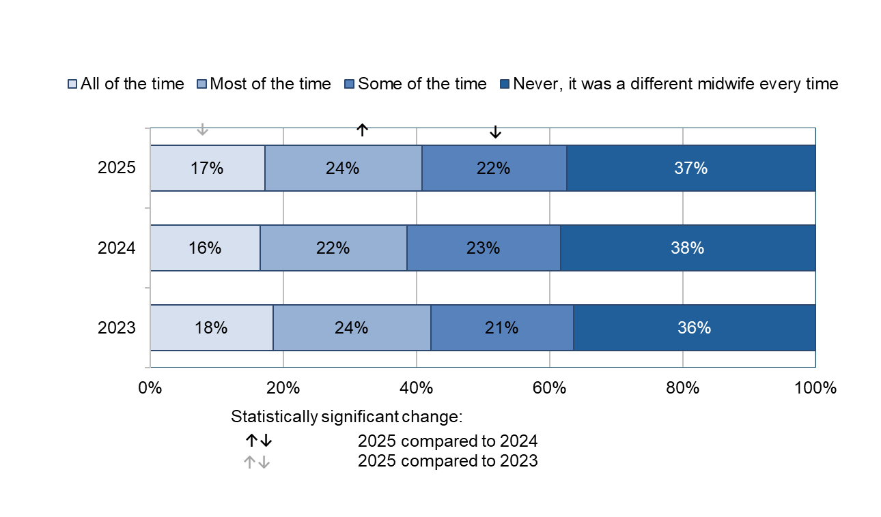Answered by all. Respondents who stated that they didn't know or couldn't remember, or did not see or speak to a midwife have been excluded. Total respondents: (2023) 17,850, (2024) 18,051, (2025) 15,997.

Of those who said that they saw or spoke to the same midwife ‘all of the time’ or ‘most of the time’ at their postnatal check-ups, the vast majority of the respondents (94% and 92%, respectively) said that their midwife or midwifery team appeared to be aware of their medical history during postnatal care. In contrast, of those who said that they had ‘a different midwife every time’ or they saw or spoke to the same midwife ‘some of the time’, 41% and 21%, respectively, said that their midwife or midwifery team did not appear to be aware of their medical history during their postnatal check-ups (figure 34).

Figure 34: Cross-tabulation of G3 (At your postnatal check-ups, how often did you see or speak to the same midwife?) [All of the time, Most of the time, Some of the time, Never, it was a different midwife every time] and G5 (Did the midwife or midwifery team that you saw or spoke to appear to be aware of the medical history of you and your baby?) [Yes, No]

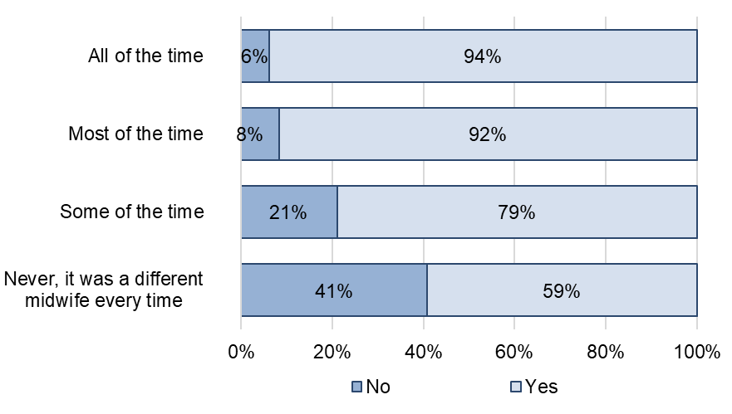

Answered by all. Respondents who stated that they didn't know or couldn't remember have been excluded. Respondents who stated that they did not see or speak to a midwife have been excluded from g5. Total number of the respondents: (All of the time) 2,619, (Most of the time) 3,505, (Some of the time) 3,126, (No, it was a different midwife every time) 5,283.

Finally, respondents were asked whether any midwives who cared for them postnatally had also been involved in their labour and antenatal care. Thirteen per cent of the respondents said that they had the same midwives involved in their postnatal care who had also been involved in their labour and antenatal care. More than half (54%) said that they had different midwives during their postnatal care to those who had been involved in their labour or antenatal care, – this has seen a statistically significant decrease compared with 56% in 2024 (figure 35).

Results for subgroup analysis shows poorer experiences overall of care if respondents had the same midwife ‘some of the time’ or ‘never’ during their antenatal check-ups (8 questions and 21 questions, respectively, addressed this). Respondents who did not have the same midwives across their antenatal care and labour and birth also reported overall poorer experiences of care (14 questions addressed this). Respondents who had the same midwife ‘some of the time’ or never’ during their postnatal check-ups reported overall poorer experiences of care (15 questions and 21 questions, respectively, addressed this).

Figure 35: Had any midwives who cared for you postnatally also been involved in your labour and antenatal care? By survey year
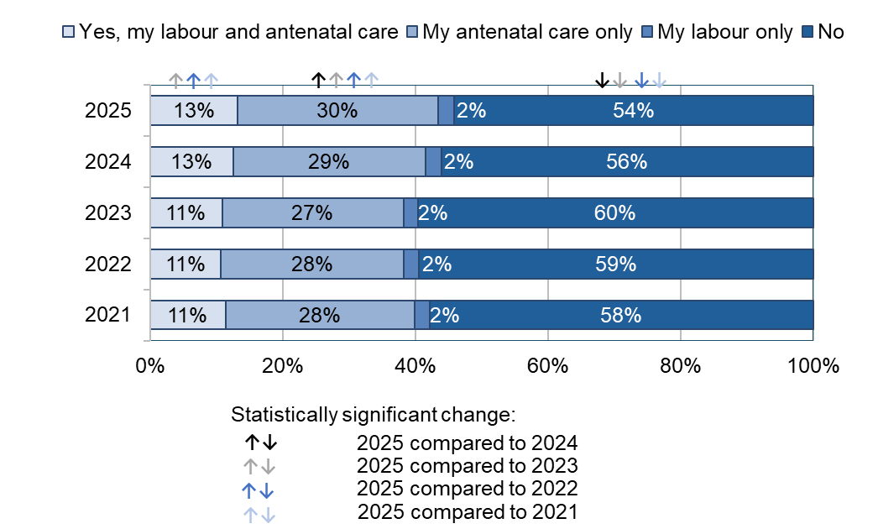

Answered by all. Respondents who stated that they didn't know or couldn't remember have been excluded. Total respondents: (2021) 22,092, (2022) 19,685, (2023) 17,802, (2024) 17,601, (2025) 15,458.

Awareness of medical history

CQC’s National review of maternity services in England 2022 to 2024 stated that midwifery continuity of carer can also be facilitated by the effective sharing of information within teams of midwives or across multidisciplinary teams. It also found that effective communication and coordination were linked to maternity staff being aware of women’s medical history and preferences about their care.

Results of the 2025 Maternity survey show that just over half (53%) of the respondents said that their midwives or doctor ‘always’ appeared to be aware of their medical history during their antenatal check-ups, while 11% said that their midwives or doctor did not appear to be aware of their medical history. For those who said that this was not the case, results show a small statistically significant decrease compared with 12% in 2024. Figure 36 indicates a significant upward trend since 2021 (53% answered ‘Yes, always’ in 2025 compared with 46% in 2021).

Figure 36: During your antenatal check-ups, did your midwives or doctor appear to be aware of your medical history? (% Yes, always)

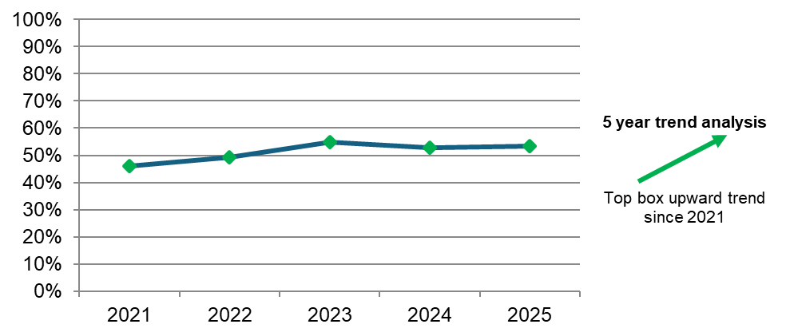
Answered by all. Respondents who stated that they didn't know or couldn't remember have been excluded. Total number of the respondents: (2021) 22,902, (2022) 20,417, (2023) 18,515, (2024) 18,556, (2025) 16,420.
A greater proportion of the respondents said that their midwives or doctor ‘always’ appeared to be aware of their medical history during their labour and birth than during their antenatal check-ups. Nearly two-thirds (65%) of the respondents said that their midwives or doctor ‘always’ appeared to be aware of their medical history during labour and birth, a statistically significant increase compared with 63% in 2024. However, nearly a quarter (24%) said that this was ‘sometimes’ the case, a statistically significant decrease compared with 26% in 2024. The remaining 11% said that this was not the case (figure 37).

Figure 37: During your labour and birth, did your midwives or doctor appear to be aware of your medical history? By survey year
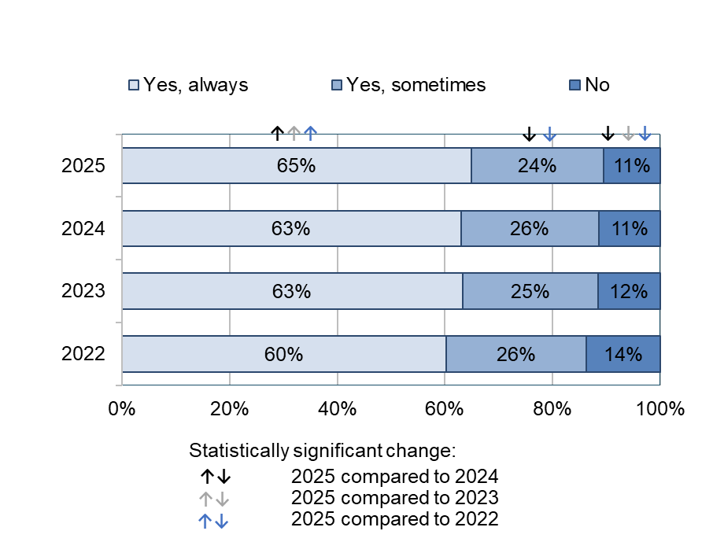

Answered by all. Respondents who stated that they didn't know or couldn't remember have been excluded. Total number of the respondents: (2022) 18,754, (2023) 17,045, (2024) 17,151, (2025) 15,193.

Likewise, more than three-quarters (77%) of the respondents said that their midwife or midwifery team appeared to be aware of their or their baby’s medical history during postnatal care. In contrast, nearly a quarter (23%) said that this was not the case. Results show that this is consistent with the 2024 results. Figure 38 demonstrates an overall upward trend since 2021 (77% answered ‘Yes’ in 2025 compared with 74% in 2021).

Figure 38: Did the midwife or midwifery team that you saw or spoke to appear to be aware of the medical history of you and your baby? By survey year

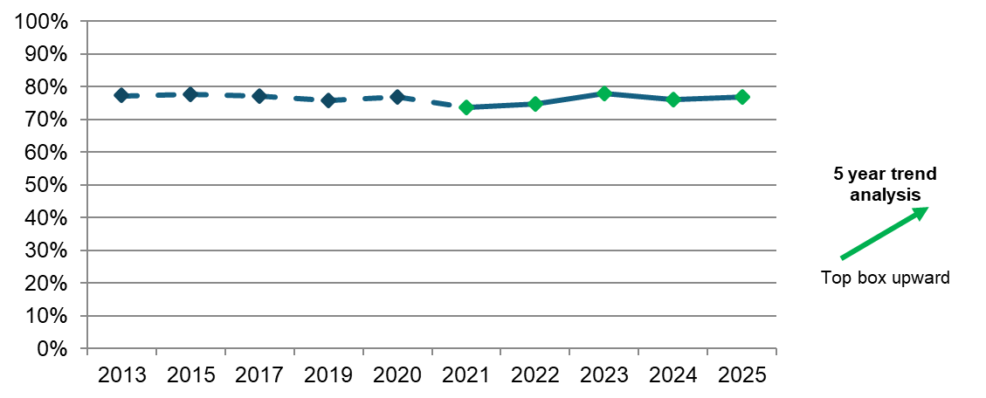
Answered by all. Respondents who stated that they didn't know or couldn't remember have been excluded. Total respondents: (2021) 20,729, (2022) 18,551, (2023) 16,561, (2024) 16,974, (2025) 15,093.

Infant feeding

NICE guidance on antenatal care recommends that midwives discuss infant feeding from 28 weeks and keep providing support and advice during the antenatal period. The NICE quality statement on breastfeeding recommends that women should be made aware of the benefits of breastfeeding and given breastfeeding support across all healthcare settings, including in hospital, primary care, and community care. However, while new parents should be informed of these benefits, women’s choices about how to feed their baby must be respected. If women make an informed decision not to breastfeed, the Royal College of Midwives states that they should be supported to feed their baby with formula.

More than half (59%) of the respondents said that they ‘definitely’ received relevant information from midwives during pregnancy about feeding their baby, a statistically significant increase compared with 56% in 2024. Conversely, 13% said that they did not receive this information, a small statistically significant decrease compared with 14% in 2024. Figure 39 shows that there has been a significant upward trend since 2021 (59% answered ‘yes, definitely’ in 2025 compared with 52% in 2021).

Figure 39: During your pregnancy, did midwives provide relevant information about feeding your baby? (% Yes, definitely)

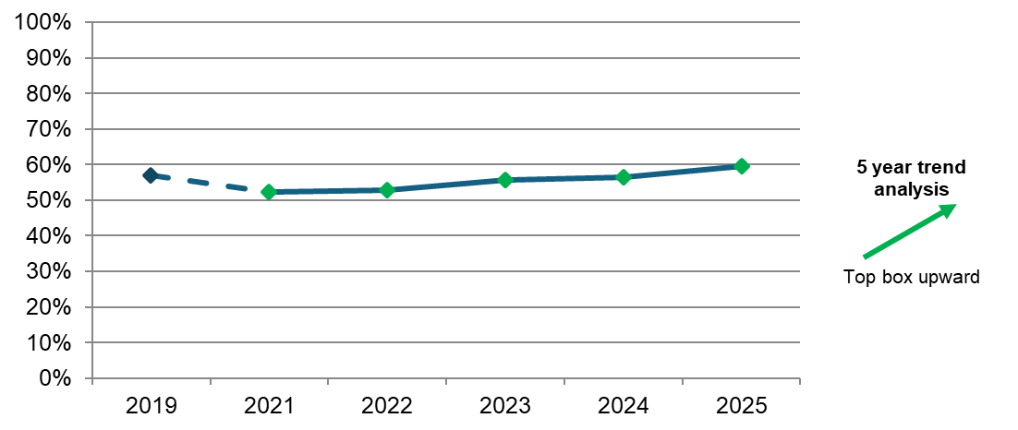
Answered by all. Respondents who stated that they didn't know or couldn't remember have been excluded. (2019) 16,668 (2021) 22,960, (2022) 20,436, (2023) 18,527, (2024) 18,486, (2025) 16,347.
The majority (84%) of the respondents reported that their decisions about how they wanted to feed their baby were ‘always’ respected by midwives during postnatal care, a statistically significant increase compared with 82% in 2024. A further 12% reported that their decisions were ‘sometimes’ respected, a small statistically significant decrease compared with 13% in 2024. Our trend analysis indicates no change since 2021.
NICE guidance on postnatal care states that breastfeeding care must be tailored to women’s individual needs, and they should be provided with information, advice, reassurance, and support.

Sixty-three per cent of the respondents answered that they were ‘always’ given enough support and advice by midwives about feeding their baby on the ward or at home, which is a significant increase compared with 60% in 2024. However, 15% answered that this did not happen – this has seen a significant decrease compared with 17% in 2024.

Likewise, more than half (57%) of the respondents said that they ‘definitely’ received help and advice from a midwife about feeding their baby in the 4 weeks after the birth, a statistically significant increase compared with 54% in 2024. More than a quarter (27%) said that they received this help and advice ‘to some extent’, consistent with the results in 2024. In contrast, 16% said that they did not receive this help and advice, a statistically significant decrease compared with 18% in 2024.

More than half (53%) of the respondents reported that they were ‘always’ able to get support and advice about feeding their baby if they needed this during evenings, nights, or weekends. This is a statistically significant increase compared with 48% in 2024. Just over a fifth (21%) reported that they were ‘sometimes’ able to get this support and advice, consistent with the results in 2024. However, more than a quarter (26%) reported that they were not able to get this support and advice – this has seen a statistically significant decrease compared with 29% in 2024. Figure 40 shows that there has been a significant upward trend since 2021 (53% answered ‘yes, always’ in 2025 compared with 48% in 2021).

Figure 40: If, during evenings, nights or weekends, you needed support or advice about feeding your baby, were you able to get this? (% Yes, always)

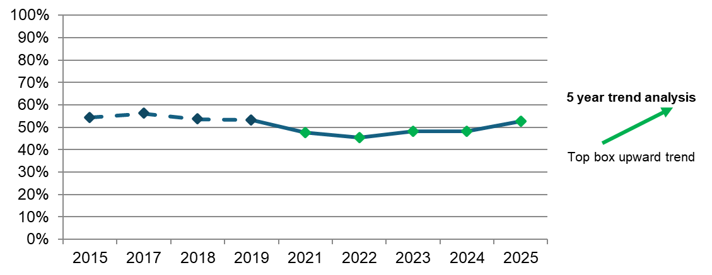
Answered by all. Respondents who stated that they didn't know or couldn't remember or did not need support or advice about feeding their baby have been excluded. (2015) 7,620, (2017) 6,151, (2018) 6,335, (2019) 6,078, (2021) 10,189, (2022) 8,780, (2023) 7,976, (2024) 7,912, (2025) 6,566.

Perinatal mental health

NICE guidance on antenatal and postnatal mental health recommends that people are asked about their emotional wellbeing throughout pregnancy and postnatal care as part of routine appointments.

Results show that more than three-quarters (77%) of the respondents said that they were ‘definitely’ asked about their mental health during their antenatal check-ups, which is a small statistically significant increase compared with 76% in 2024. The proportion of the respondents who said that they were ‘to some extent’ asked about their mental health was 18%, which is a statistically significant decrease compared with 20% in 2024. Figure 41 shows that there has been a significant upward trend since 2021 (77% answered ‘yes, definitely’ in 2025 compared with 69% in 2021).

Figure 41: During your antenatal check-ups, did your midwives ask you about your mental health? (% Yes, definitely)

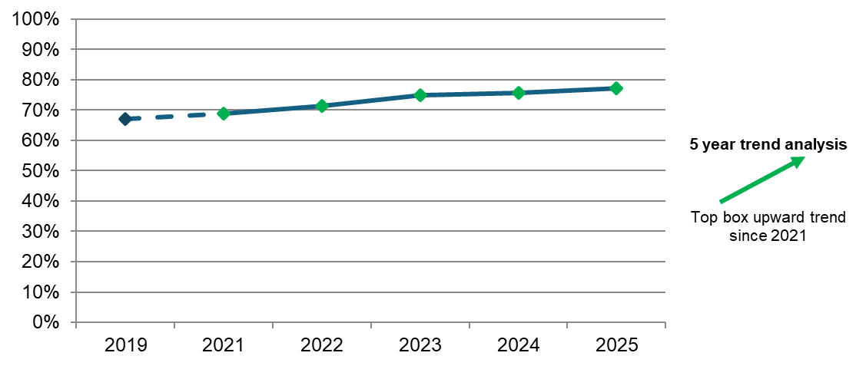
Answered by all. Respondents who stated that they didn't know or couldn't remember have been excluded. Total number of the respondents: (2019) 16,606, (2021) 23,052, (2022) 20,585, (2023) 18,671, (2024) 18,661, (2025) 16,482.
In terms of support with mental health postnatally, the vast majority (94%) of the respondents said that a midwife did ask them about their mental health after they left hospital. This is consistent with the results from the 2024 survey.

NICE guidance on antenatal and postnatal mental health states that mental health professionals should provide culturally relevant information on mental health problems in pregnancy and the postnatal period. This should ensure that women understand that mental health problems during pregnancy and the postnatal period are not uncommon and reassure them about treatment options.

The large majority (90%) of the respondents reported being given enough support for their mental health during their pregnancy, a small statistically significant increase from 89% in 2024. Meanwhile, 1 in 10 (10%) reported that they were not given enough support – this has seen a small statistically significant decrease from 11% in 2024. Figure 42 shows that there has been a significant upward trend since 2021 (90% answered ‘yes’ in 2025 compared with 83% in 2021).

Figure 42: Were you given enough support for your mental health during your pregnancy? (% Yes)

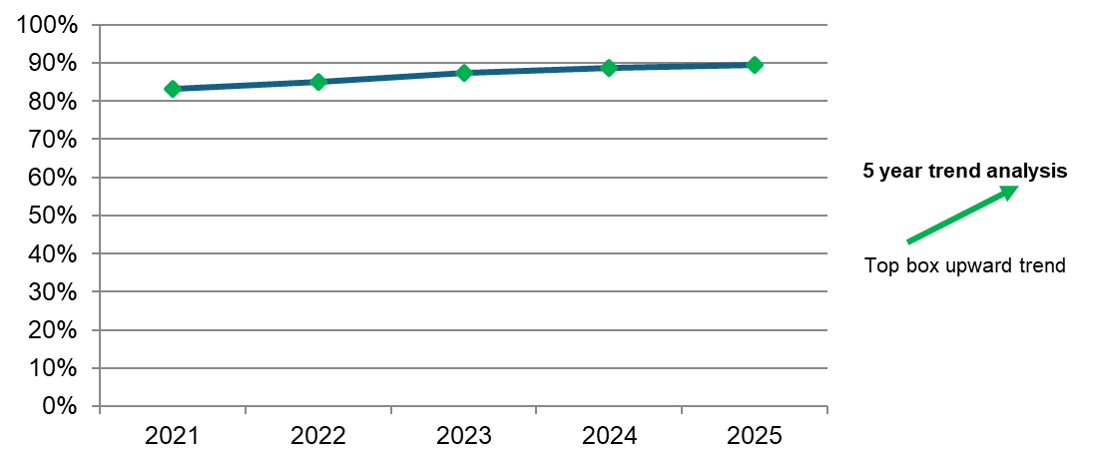
Answered by all. Respondents who stated that they didn't know or couldn't remember or did not want or need support have been excluded. Total number of the respondents: (2021) 14,217, (2022) 12,544, (2023) 11,643, (2024) 11,784, (2025) 10,361.
Sixty-one per cent of the respondents said that they were ‘definitely’ given information about any changes they might experience to their mental health after having their baby. This is a significant increase compared with 58% in 2024. However, 14% said that they were not given this information after having their baby, a small statistically significant decrease compared with 15% in 2024. Figure 43 shows an overall upward trend since 2021, which we found as part of our trend analysis spanning a 5-year period, since 2021 (56%).

Figure 43: Were you given information about any changes you might experience to your mental health after having your baby? (% Yes, definitely)

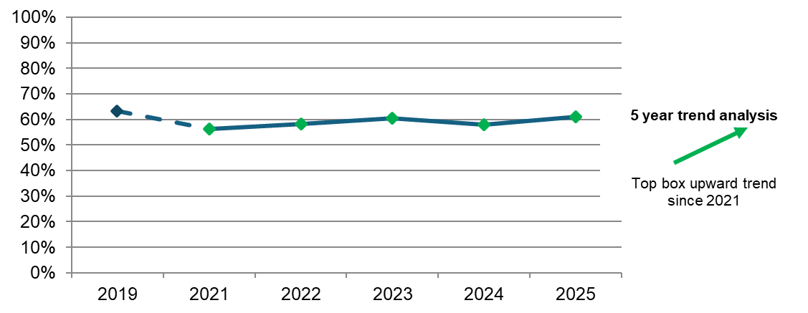
Answered by all. Respondents who stated that they didn't know or couldn't remember have been excluded. Total respondents: (2019) 16,362, (2021) 22,552, (2022) 20,104, (2023) 18,225, (2024) 18,105, (2025) 15,941.
Finally, most respondents (83%) reported that they were told who to contact if they needed advice about any changes to their mental health after birth, a statistically significant increase compared with 81% in 2024. However, 17% reported that they were not given this information, although this has seen a statistically significant decrease compared with 19% in 2024. Figure 44 shows a significant upward trend since 2021 (79%).

Figure 44: Were you told who you could contact if you needed advice about any changes you might experience to your mental health after the birth? (% Yes)

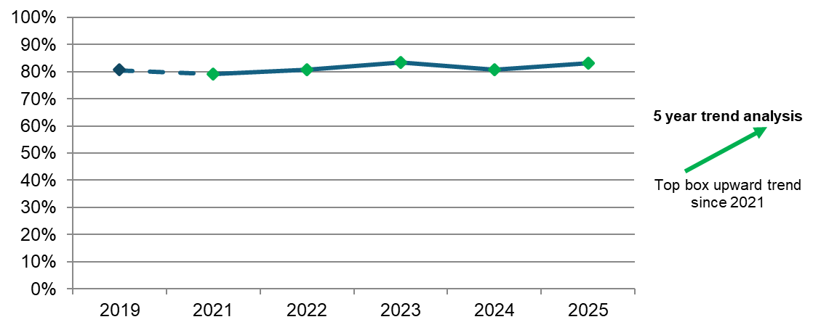
Answered by all. Respondents who stated that they didn't know or couldn't remember have been excluded. Total respondents: (2019) 14,829, (2021) 20,728, (2022) 18,553, (2023) 16,720, (2024) 16,549, (2025) 14,667.

Subgroup analysis

We looked at how different groups of women rated their experience by using a multi-level model analysis. The analysis compares the average probability that different subgroups of women select the most positive answer to a survey question (‘theme’). The subgroups included in the analysis are:
- age
- parity (whether women have had a previous baby or not)
- type of delivery
- ethnicity
- religion
- sexual orientation
- gender same as sex assigned at birth
- Indices of Multiple Deprivation (IMD) decile
- long-term health conditions
- pregnancy-related conditions
- whether English is spoken as their main language
- frequency of contact with the same midwife during antenatal care
- frequency of contact with the same midwife during postnatal care
- continuity of midwife across antenatal care, and labour and birth.

See the Quality & Methodology Report for more details on the methodology used for the analysis. The following tables illustrate the findings of the subgroup analysis. Findings significantly above (B) or significantly below (W) average are shown for each survey question under each theme. There were no differences in experience found for sexual orientation and gender same as sex assigned at birth, therefore, these subgroups have not been included in the tables that follow.

The patterns that we observed do not align with those reported elsewhere regarding differences in experience between ethnic groups. Further work is needed to understand and explore this discrepancy.

 |  | Antenatal care |  |  |  |  | Labour and birth |  |  |  |  |  |  |  | Ward |  |  |  | Postnatal care
predictor | subgroup | b6: Being listened to by midwives | b9: Being given the help needed | b11: Involved in decisions | b13: Confidence and trust | b14: Respect and dignity | c8: Pain management | c11: Left alone when worried | c12: Concerns taken seriously | c13: Access to help when needed | c16: Involved in decisions | c17: Respect and dignity | c18: Confidence and trust | c21: Kindness and compassion | d3: Access to help when needed | d4: Information or explanations | d5: Kindness and understanding | d7: Pain management | g1: Involved in decisions | g2: Access to help when needed | g4: As much contact as wanted | g6: Being listened to | g8: Confidence and trust
Continuity of care - antenatal | All of the time | B | B | B | B | B | B | B | B | B | B | B | B | B | B | B | B | B | B | B |  | B | B
Continuity of care - antenatal | Most of the time | B | B |  | B | B |  |  |  |  |  |  |  | B | B | B | B |  | B | B |  | B
Continuity of care - antenatal | Some of the time | W | W | W | W | W |  |  |  | W |  |  |  |  |  |  | W |  | W
Continuity of care - antenatal | Never | W | W | W | W | W | W | W | W | W | W | W | W | W | W | W | W | W | W | W |  | W | W
Continuity of care - labour and birth | Yes, my labour and antenatal care | B | B |  | B |  | B |  |  |  | B |  | B |  | B | B | B | B | B | B |  | B | B
Continuity of care - labour and birth | My antenatal care only |  | W |  |  |  | W |  |  |  | W |  | W |  | W | W | W | W
Continuity of care - labour and birth | My labour only
Continuity of care - labour and birth | No | W | W |  | W | W |  |  |  |  | W |  | W |  | W | W | W | W | W | W |  | W | W
Continuity of care - postnatal | All of the time | B | B |  | B | B | B |  | B | B | B | B | B | B | B | B | B | B | B | B |  | B | B
Continuity of care - postnatal | Most of the time | B | B |  | B |  | B |  | B | B |  |  | B |  |  | B | B | B | B | B |  | B | B
Continuity of care - postnatal | Some of the time | W | W |  | W |  | W |  |  | W |  |  | W | W | W | W | W | W | W | W |  | W | W
Continuity of care - postnatal | Never | W | W | W | W | W | W |  | W | W | W | W | W | W | W | W | W | W | W | W | W | W | W
Type of delivery | Vaginal | B |  | B | B | B | B |  |  | B | B | B | B | B | B | B | B | B | B | B |  | B | B
Type of delivery | Assisted vaginal |  |  |  |  |  |  | W | W |  | W | W | W | W | B
Type of delivery | Planned caesarean |  |  |  |  |  |  | B | B | B | B | B | B | B | W |  |  | W | W | W |  | W
Type of delivery | Emergency caesarean | W |  | W | W | W |  | W | W | W | W | W | W | W | W | W | W | W | W | W |  | W | W
Age | 16-26 |  | W |  |  | W |  | W |  | W |  | W |  | W
Age | 27-32 |  | B |  |  |  |  |  |  |  |  | B |  | B
Age | 33+ |  | B |  |  | B |  | B |  | B |  | B |  | B
Parity | Primiparous (no previous births) |  |  |  |  |  | W |  |  |  |  |  |  |  |  | W | W |  | W |  | W
Parity | Multiparous (1 or more previous births) |  |  |  |  |  | B |  |  |  |  |  |  |  |  | B | B |  | B |  | B
English main language | Yes (English main language) | W |  |  | W | W |  |  | W | W | W | W | W | W | W | W | W | W |  |  | B | W
English main language | No (English main language) | B |  |  | B | B |  |  | B | B | B | B | B | B | B | B | B | B |  |  | W | B
Religion | No religion
Religion | Buddhist
Religion | Christian |  |  |  |  |  |  |  |  |  |  |  |  |  |  |  |  |  |  |  |  | B
Religion | Hindu
Religion | Jewish |  |  |  |  |  |  |  |  |  |  |  |  |  | W
Religion | Muslim
Religion | Sikh |  |  |  |  |  |  |  |  |  |  |  |  |  | B
Religion | Other (religion)
Religion | I would prefer not to say (religion) |  |  |  |  |  |  |  |  | W |  |  | W | W | W |  |  | W |  |  |  | W
Ethnicity | English / Welsh / Scottish / Northern Irish / British
Ethnicity | Irish
Ethnicity | Any other White background (including Gypsy or Irish Traveller and Roma) |  |  |  | W
Ethnicity | White and Black Caribbean
Ethnicity | White and Black African
Ethnicity | White and Asian
Ethnicity | Any other Mixed / multiple ethnic background
Ethnicity | Indian
Ethnicity | Pakistani
Ethnicity | Bangladeshi
Ethnicity | Chinese
Ethnicity | Any other Asian background
Ethnicity | African | B |  |  | B |  |  |  |  |  | B |  |  |  |  | B
Ethnicity | Caribbean |  |  |  |  |  |  |  |  |  |  |  |  |  |  | B
Ethnicity | Arab
Ethnicity | Any other ethnic group
Ethnicity | I would prefer not to say (ethnicity)
Index of Multiple Deprivation decile (IMD) | 1st decile |  |  |  |  | W
Index of Multiple Deprivation decile (IMD) | 2nd decile
Index of Multiple Deprivation decile (IMD) | 3rd decile
Index of Multiple Deprivation decile (IMD) | 4th decile
Index of Multiple Deprivation decile (IMD) | 5th decile
Index of Multiple Deprivation decile (IMD) | 6th decile
Index of Multiple Deprivation decile (IMD) | 7th decile
Index of Multiple Deprivation decile (IMD) | 8th decile
Index of Multiple Deprivation decile (IMD) | 9th decile
Index of Multiple Deprivation decile (IMD) | 10th decile |  |  |  |  | B
Long-term health conditions | Autism or autism spectrum condition
Long-term health conditions | Breathing problem, such as asthma
Long-term health conditions | Blindness or partial sight
Long-term health conditions | Deafness or hearing loss
Long-term health conditions | Diabetes
Long-term health conditions | Heart problem, such as angina
Long-term health conditions | Joint problem, such as arthritis
Long-term health conditions | Kidney or liver disease
Long-term health conditions | Learning disability
Long-term health conditions | Mental health condition |  |  |  |  |  |  |  |  |  |  |  |  |  |  |  | W
Long-term health conditions | Neurological condition
Long-term health conditions | Physical mobility condition
Long-term health conditions | Thalassaemia
Long-term health conditions | Another long-term condition
Long-term health conditions | None of the above (long-term health conditions)
Long-term health conditions | I would prefer not to say (long-term health conditions) |  |  |  |  | W
Long-term health conditions | Pelvic health problems | W |  |  |  |  |  |  |  |  |  |  |  |  |  |  |  | W
Long-term health conditions | Another pregnancy-related health condition |  |  |  |  |  |  |  |  |  |  |  |  |  |  |  |  |  | W
Long-term health conditions | None of the above
Long-term health conditions | I would prefer not to say (pregnancy-related conditions) | W

Appendix A: Survey methodology
This appendix summarises the survey methodology, covering questionnaire design, sampling, fieldwork, and analysis. The Quality & Methodology Report contains further detail, including information on data limitations.
Questionnaire design
To make sure that the questionnaire is up-to-date and in line with current policy and practice, questions are reviewed before each survey to determine whether any new questions are needed. Questionnaire development work makes sure that the questions are important to people who use services and other stakeholders who use the survey data in their work. More information on how survey stakeholders use the data is provided in Appendix D.
Wherever possible, questions remain the same over time to measure change. However, when necessary, they are updated to reflect changes in policy and methodological best practice, and to reflect feedback from stakeholders, to make sure that questions stay relevant. Full details of changes are available in the Survey Development Report.
Comparability with previous years
The Maternity survey was first run in 2007, with surveys being carried out in 2010, 2013, 2015, 2017, 2018, 2019, 2021, 2022, 2023, 2024, and 2025.
The survey questionnaire underwent a major redevelopment ahead of the 2013 survey so results for 2025 are only comparable with 2013, 2015, 2017, 2018, 2019, 2021, 2022, 2023, 2024 and, 2025.
Survey methodology
The 2025 Maternity survey used both an online and a postal questionnaire for survey data collection. People using maternity services were sent a maximum of 4 postal letters inviting them to complete the survey. In addition to the letters, they were sent up to 3 text message (SMS) reminders containing a direct link to the online survey. This is discussed further in the Quality & Methodology Report.
The survey used a ‘push to web’ methodology, meaning that people were encouraged to complete it online. A paper questionnaire was enclosed in the third mailing with all other contacts providing a web link. Ninety per cent of the respondents took part online.
Fieldwork for the survey (the time during which respondents were invited to take part in the survey) took place between April and July 2025.
The 2025 survey offered several accessible formats of the questionnaire to ensure that it followed best practice for survey accessibility. The online survey was translated into 9 non-English languages. Additionally, respondents were able to change the font size and background colour of the online survey, and the survey was designed to be screen reader compatible. Braille, large print, and Easy Read paper questionnaires were available on request.

Accessibility formats | Number of requests received
Non-English online completes | 316
Braille requests | 0
Large print requests | 0
Easy read requests | 0
Telephone assisted completes | 1
Telephone calls requiring translator | 1

Response rate
The response rate for the 2025 survey was 39%, compared with that for the previous survey in 2024 (41%).
Sampling
Women aged 16 and over at the time of delivery were eligible to complete the survey, if they had a live birth during the month of February 2025. Trusts with sample sizes smaller than 300 were also required to include people who gave birth during January 2025, starting with deliveries on 31 January and working back across the month until the sample size of 300 was achieved or 1 January was reached. Only those receiving care from an NHS trust were eligible. The sample size was sufficient to allow analysis of results at individual trust level.
Certain groups of people were excluded from the survey before providers drew their samples, including those whose baby had died, people who died, those who had a concealed pregnancy, and people whose baby was fostered or adopted.
All NHS trusts providing maternity services and that had enough births were eligible to take part in the survey.
No trusts were excluded from the analysis because of sampling errors.
More detailed information on the sampling for the survey is available in the instruction manual.
Analysis

Data cleaning
‘Data cleaning’ refers to all the editing processes carried out on survey data once the survey has been completed and the data has been entered and collated. This is done to make sure that this is comparable across trusts. For further information see the Data Cleaning Guidance.

Weighting
The data presented in this report has been weighted with 2 weights:
- ‘Trust weight’ aims to weight responses from each trust to ensure that each trust has an equal influence on England results. As some trusts have a higher response rate than others, they have a larger share of the respondents in the total respondent’s population for England.
- ‘Population weight’, ensures that responses for each individual are weighted to make sure they are representative of the trust’s own population (based on the initial eligible sample). This involves weighting based on variables that are related to how people respond. For the 2025 Maternity survey, this variable is age group.

Both sets of weights are then multiplied together to produce a single combined weight for the data tables that underpin the analysis. The demographic questions (H1-H11 and H13-H14 in the questionnaire) are not weighted, as it is more appropriate to present the real percentages of the respondents to describe the profile of the respondents, rather than to adjust figures.

Rounding
The results present percentage figures rounded to the nearest whole number, so the values given for any question will not always add up to 100%.

Statistical significance
Statistical tests were carried out on the data to determine whether there had been any statistically significant changes in the results for 2025 compared with the results for 2024, 2023, 2022, and 2021.
A ‘t-test’ set to 95% significance was used to compare data between 2 survey years. A statistically significant difference means that there is a less than 5% chance that we would have obtained this result if there was no real difference.

In other cases, even though there might be a visible change in the results between either 2021, 2022, 2023, or 2024 compared with 2025, it is not significant. There are several reasons for this, such as:
- Rounding figures up or down makes a difference appear larger than it actually is.
- The larger the sample size, the more likely it is that the findings will be statistically significant, and we can be more confident in the result. In contrast, the fewer the people who answer a question, there greater the difference required for statistical significance.

The amount of variation also affects whether the difference is significant. ‘Variation’ refers to the differences in the way people respond to a question. If there is a lot of variation, differences are less likely to be statistically significant.
The Quality & Methodology Report contains relevant background information to help readers to understand the survey data, including response rates, sampling errors, and data limitations.

Appendix B: Other sources of data related to the key findings
There are multiple sources of data on maternity care. The information below provides links to some of these.
Note: These data sources do not measure service user experience and are therefore not directly comparable with findings presented in this report. However, they provide useful contextual information.

Breastfeeding at 6-8 weeks after the birth
The Office of Health Improvements and Disparities’ annual datasets and commentary on the number and proportion of infants who have been fully, partially, or not at all breastfed at 6 to 8 weeks after birth.

HES data
NHS England’s Hospital Episode Statistics (HES) is a data warehouse containing details of all admissions, outpatient appointments, and A&E attendances at NHS hospitals in England.
The maternity publication describes activity in England and includes national and provider level information on delivery, mother’s age, complications, and more.

Live births
The Office for National Statistics (ONS) publishes annual statistics on live births by age of mother/father, sex, marital status, country of birth, socio-economic status, previous children, and area.

Maternity Services Data Set
NHS England’s Maternity Services Data Set captures patient-level information about activity carried out by maternity services relating to a mother and baby(s), from the point of the first booked appointment to the moment when the mother and baby(s) are discharged from maternity services.
It was established in response to NHS England’s Better Births, which recommended that a nationally agreed set of indicators be developed to help local maternity systems track, benchmark, and improve the quality of maternity services. Data is published monthly.

Friends and Family test
NHS England’s Friends and Family Test gives patients the opportunity to submit feedback to providers of NHS funded care or treatment, using a single question about how likely, on a scale ranging from extremely unlikely to extremely likely, they are to recommend the given service to their friends and family if they needed similar care or treatment. Data is published on a monthly basis.

Child and infant mortality in England and Wales
The ONS provides data on stillbirths, infant and childhood deaths occurring annually in England and Wales, and associated risk factors.

MBRRACE-UK surveillance data collection system
The Mothers and Babies: Reducing Risk through Audits and Confidential Enquiries across the UK (MBRRACE-UK) surveillance data collection system collects data on maternal and perinatal deaths in England, Wales, and Scotland. Modified arrangements are in place for Northern Ireland.

Statistics of Women’s Smoking Status at Time of Delivery: England
This NHS England dataset presents statistics on women’s smoking status at time of delivery, at Sub integrated care board location, integrated care board, and national levels.

NHS Outcomes Framework
The Department of Health and Social Care’s NHS Outcomes Framework provides national accountability for the outcomes that the NHS delivers, to drive transparency, quality improvement, and outcome measurement across the NHS.
Data from the NHS Patient Survey Programme is used to monitor domain 4, ‘ensuring that people have a positive experience of care’. Data from the Maternity survey is used to populate domain 4.5, ‘women’s experience of maternity services’.

Staffing
Statistics on staffing numbers are provided in NHS Digital’s statistical release on NHS Workforce Statistics.
Note: this data covers all trust types (not just acute trusts with maternity services).

Appendix C: Other maternity surveys
There have previously been a number of surveys of maternity care experiences – this appendix covers only results from those surveys that have been updated since 2021.
Note: Surveys use different methodologies and questionnaires, have different aims and purposes, and have been carried out at different points in time. This means that comparisons with this survey must be considered with significant caution.
However, a common theme across most surveys, including internationally, is that women tend to report more positive experiences of their antenatal care, and labour and birth than their postnatal care.

Black Maternity Experiences Survey
The second iteration of the Black Maternity Experiences Survey was launched in February 2025, and aims to better understand the experiences of Black women using maternity services, including their experiences of childbirth, to facilitate change. It is run by Five X More, a grassroots organisation committed to changing Black women’s maternal health outcomes in the UK.
Using a survey designed with input from an expert panel of Black professionals, both quantitative and qualitative data was gathered from 1,264 respondents from around the UK who either identified as Black or of Black mixed heritage and had accessed NHS maternity services while pregnant between July 2021 and March 2025.
The findings showed good or high-quality experiences of antenatal care. However, care during labour and birth, and postnatal care highlighted issues with communication, pain management, and interactions with healthcare professionals. The findings were found to fit within 5 related themes centred around structural and interpersonal factors:
- begging to be believed (for example, not being listened to by healthcare professionals; delays in responding to urgent symptoms)
- experiences of racism and cultural harm (for example, being judged or treated differently due to their race and ethnicity)
- advocacy and unequal power dynamics (for example, needing to advocate strongly for themselves in order to receive safe and respectful care)
- missed accountability and unresolved harm (for example, not lodging a formal complaint due to emotional exhaustion and a lack of information about the process)
- positive experiences (for example, being treated with compassionate care, consistency, and connection).

The National Perinatal Epidemiology Unit
The National Perinatal Epidemiology Unit has conducted a survey of experiences of maternity care in 2006, 2010, 2014, 2018, 2020, and 2024. The surveys collect information on respondents’ experiences of pregnancy, labour, birth, and early parenthood, which is used to improve maternity services across the country. The Care Quality Commission worked with the Unit to develop the first Maternity Survey in the NHS Patient Survey Programme.

Scotland
The Maternity Care Survey carried out by the Scottish Government is very similar to the NHS Maternity survey, and covers the maternity care journey from antenatal care through to care at home after the birth. The questionnaire uses many of the questions from the English survey and uses a similar methodology. The survey ran in 2013, 2015 and, 2018, and the fieldwork for the 2025 survey is open until January 2026.

Wales
A national review of maternity services was carried out across Wales, with phase 1 of the review taking place from June 2019 to summer 2020. In July 2021 the decision was made not to progress with phase 2 of the review.

Northern Ireland
A Birth NI survey has not been carried out in Northern Ireland since 2016.

International surveys
This section highlights maternity surveys carried out in other countries. While results are not directly comparable due to different healthcare systems and different survey methodologies, these surveys might be of interest and a selection is summarised below.

Republic of Ireland
The second National Maternity Experience Survey took place in February and March 2025. It offered eligible new mothers the opportunity to share their experiences of Ireland’s maternity services — from antenatal to postnatal care — in order to improve the safety and quality of care provided to women and their babies. The findings of the survey will be published at the end of 2025.

California – USA
The Listening to Mothers surveys cover the time from before pregnancy through to the postpartum and infancy periods, and focus on attitudes, beliefs, preferences, and knowledge on a broad range of topics. The 2025 ‘Listen to Mothers IV’ survey is currently in its fieldwork stage. The results are due to be published in early 2026.

Appendix D: Main uses of the survey data
This appendix lists known users of data from the Maternity survey and how they use the data.

Care Quality Commission
The Care Quality Commission (CQC) will use results from the survey to build an understanding of the risk and quality of services and those who organise care across an area. Where survey findings provide evidence of a change to the level of risk or quality in a service, provider, or system, CQC will use the results alongside other sources of people’s experience data to inform targeted assessment activities.

Department of Health and Social Care
The government measures progress on improving people’s experiences through domain 4 of the NHS Outcomes Framework, ‘ensuring people have a positive experience of care’. The framework sets out the outcomes and corresponding indicators that the Department of Health and Social Care uses to hold NHS England to account for improvements in health outcomes.
The NHS Outcomes Framework survey indicators are based on the standardised, scored trust-level data from the survey (similar to that included in CQC’s benchmark reports), rather than the England-level percentage of respondent’s data that is contained within this report.

NHS England
NHS England is a key user of data from the NHS Patient Survey Programme. Listening to people’s experiences of their maternity care plays a crucial part in delivering services that are safe, effective, and continuously improving. Data from the Maternity survey are important for NHS England to understand experiences of the services across the whole maternity pathway.
Patient experience is a cross-cutting theme throughout the NHS Long Term Plan. CQC data supports NHS England to track how it is performing on user experience, understand where inequality is present, and track the impact that policy initiatives are having on patients.
NHS services have suffered a heavy burden from the COVID-19 pandemic, with the 2024/25 priorities and operational planning guidance reconfirming the ongoing need to recover core services and improve productivity. CQC data supports NHS England to understand how they could do this in an equitable way.
For more information see NHS England’s webpage on National Patient and Staff Surveys.
NHS England’s Three year delivery plan for maternity and neonatal services includes measures for determining success that are used to monitor outcomes and progress in achieving key objectives on the plan. The measures are organised by 4 themes that underpin the three-year delivery plan. For Theme 1, ‘Listening to and working with women and families with compassion’, 10 measures are linked to the CQC Maternity survey questions. These measures, classed as outcomes, include:
- Awareness of medical history during antenatal check-ups
- Involvement in antenatal care decisions
- Being listened to during antenatal check-ups
- Response to concerns during labour and birth
- Involvement in decisions during labour and birth
- Kind and compassionate treatment during labour and birth
- Adequacy of information or explanations during postnatal hospital care
- Consideration of personal circumstances during postnatal care
- Being listened to during postnatal care
- Adequacy of time discussing physical and mental health at the 6-8 weeks GP check.

The construction of each outcome measure is detailed in this technical guidance.

NHS trusts and commissioners
Trusts, and those that commission services, use the results to identify and make the changes they need to improve the experience of people who use their services.

Patient Experience Library
Data from the NHS Patient Survey Programme is added to the Patient Experience Library’s Surveys Tracker, which brings all survey data and benchmark reports into 1 place, cross referencing them with common themes such as cleanliness and waiting.
The tracker was developed based on discussions with NHS England’s heads of Patient Experience Network, whose members find it invaluable for helping boards and senior management of trusts to get quick and easy access to these key components of patient experience evidence.
The tracker is open access, so it is also available to patient groups, health charities, policy bodies, and researchers. Summaries of each survey also appear in the Library’s annual Patient Experience in England report, which is disseminated to around 2,000 individuals and organisations with an interest in patient experience and involvement.

Appendix E: Revisions and corrections
The Care Quality Commission (CQC) publishes a revisions and corrections policy relating to these statistics. Maternity survey data is not subject to any scheduled revisions as it captures the views of women on their experiences of care at a specific point in time. All new survey results are therefore published on CQC’s website and NHS Patient Surveys, as appropriate. Previously published results are not revised.
This policy sets out how CQC will respond if an error is identified in a survey and it becomes necessary to correct published data or reports.

Appendix F: Further information and feedback

Further information
This report, together with the trust-level results, is available on the Care Quality Commission’s (CQC) website. You can also find a technical document on the NHS Patient Surveys website, which describes the methodology for producing trust-level results. The website also presents a Quality & Methodology Report, which provides information about survey methodology.
All survey reports, instructions, and documents created as part of the survey can be found on the NHS Patient Surveys website. These include full details of the methodology for the survey, questionnaires, letters sent to people invited to take part in the survey, instructions on how to carry out the survey, and the Survey Development Report.
There is more information on the NHS Patient Survey Programme, including results from other surveys and a programme of current and forthcoming surveys, on the NHS Patient Surveys website.

Further questions or feedback
This summary has been produced by CQC’s Research team, and reflects the findings of the 2025 Maternity survey. We welcome all feedback on the survey findings and the way we have reported the results, particularly from people using services, their representatives, and those providing services. If you have any comments, questions or suggestions on how this publication could be improved, please contact Patient.Survey@cqc.org.uk.
CQC will review your feedback and use it as appropriate to improve the statistics that we publish across the NHS Patient Survey Programme.
If you would like to be involved in consultations or receive updates on the NHS Patient Survey Programme, please subscribe via the CQC website.

Accredited Official Statistics status
Accredited Official Statistics status means that official statistics meet the highest standards of trustworthiness, quality, and public value.
All official statistics should comply with all aspects of the Code of Practice for Statistics. They are awarded Accredited Official Statistics status following an assessment by the Authority’s regulatory arm. The Authority considers whether the statistics meet the highest standards of Code compliance, including the value they add to public decisions and debate.
References

The ‘adjusted’ response rate is shared in this report. The adjusted base is calculated by subtracting the number of questionnaires returned as undeliverable, and the number of questionnaires sent to recipients who have died, from the total number of questionnaires disseminated. The adjusted response rate is then calculated by dividing the number of returned useable questionnaires by the adjusted base.
Fifteen out of 22 questions addressed this, including those on access to help when needed during labour and birth, and seeing a midwife as much as respondents wanted to during postnatal care.
Six questions addressed this, including those on access to help when needed during antenatal care, and being left alone when it worried respondents during labour and birth.
Eight questions, and 21 questions, respectively, addressed this, including those on involvement in decisions and being given help when needed during antenatal care.
Fourteen questions addressed this, including those on access to help when needed during antenatal care, and involvement in decisions during labour and birth.
Fifteen questions, and 21 questions, respectively, addressed these, including those on access to help when needed during care in hospital after birth and during postnatal care at home.
Assisted vaginal delivery is a vaginal birth assisted by forceps or ventouse suction cup.
Six out of 8 labour and birth questions addressed this, including those on concerns being taken seriously and being treated with respect and dignity.
Five out of 9 postnatal questions addressed this, including those on being treated with kindness and understanding, and access to help when needed.
Nineteen questions addressed this, including those on midwives listening to respondents during postnatal care, and kindness and understanding during care in hospital after birth.
Four out of 9 postnatal questions addressed this, including those on respondents being given the information or explanations they needed, and seeing a midwife as much as they wanted to.
In this report, we refer to ‘women’, but we recognise that some transgender men, non-binary people and people with variations in sex characteristics or who are intersex may also use maternity services.
This question is multiple choice so percentages will add up to more than 100%.
The IMD is the official measure of relative deprivation in England. This ranks neighbourhoods based on their deprivation and then divides them into 10 groups (deciles) based on their deprivation rank where 1 is the most deprived and 10 is the least deprived.
For example, ‘Mothers and Babies: Reducing Risk through Audits and Confidential Enquiries across the UK report (2025)’ on maternal mortality during 2021-2023, and ‘Mothers and Babies: Reducing Risk through Audits and Confidential Enquiries across the UK report (2025)’ on perinatal deaths of babies born in 2023.
Please note that some questions have been revised since 2013 and are therefore not comparable over time.
NHS England, 2025. Review of progress in 2024/2025: delivering the equality objectives and meeting the wider equality requirements. Available online at: https://www.england.nhs.uk/long-read/review-of-progress-in-2024-25-delivering-the-equality-objectives-and-meeting-the-wider-equality-requirements/
Care Quality Commission, 2023. The state of health care and adult social care in England 2022/23. Available online at: State of Care 2022/23 - Care Quality Commission (cqc.org.uk)
Midwifery, 2015. A balancing act in an unknown territory: A meta synthesis of first-time mothers׳ experiences in early labour. Available online at: http://www.midwiferyjournal.com/article/S0266-6138(14)00262-9/pdf
British Medical Journal, 2017. Sociodemographic differences in women’s experience of early labour care: a mixed methods study. Available online at: https://bmjopen.bmj.com/content/7/7/e016351
NHS England, 2023. Three-year delivery plan for maternity and neonatal services. Available online at: NHS England » Three year delivery plan for maternity and neonatal services

